**A**

**PROJECT REPORT**

on

**“Accommodation Solution for Students and Bachelors - ApnaPG”**

Submitted in partial fulfillment for the award of degree of

**BACHELOR OF TECHNOLOGY**

**Information Technology**

Submitted by

**1. Pravin Mhaske (20141240)**

**2. Ayush Vaidya (20141217)**

**3. Amit Kumar (20142201)**

**4. Prashanti Patil (20141152)**

Under the Guidance

**Prof. Dr. S. J. Wagh**

Co-Guide

**Dr. A. M. Patokar**



**GOVERNMENT COLLEGE OF ENGINEERING, KARAD**

**(An Autonomous Institute of Government of Maharashtra)**

Academic Year 2023-2024

**Government College of Engineering, Karad**

**(An Autonomous Institute of Government of Maharashtra)**



***CERTIFICATE***

This is to certify that the project entitled “**Accommodation Solution for Students and Bachelors – ApnaPG**” has been carried out by team:

Pravin Mhaske (20141240)

Ayush Vaidya (20141217)

Amit Kumar (20142201)

Prashanti Patil (20141152)

of Final Year B. Tech. I.T. class under the guidance of **Prof. Dr. S. J. Wagh** during the academic year 2023 -24 (Semester-VIII).

|  |  |
| --- | --- |
|  |  |
| Prof.Dr. S. J. Wagh | Prof. Dr. S. J. Wagh |
| **Internal Supervisor** | **Head, IT Dept** |

**External Examiner**

**Government College of Engineering, Karad**

**(An Autonomous Institute of Government of Maharashtra)**



***CERTIFICATE***

This is to certify that the project entitled “**Accommodation Solution for Students and Bachelors – ApnaPG**” has been carried out by team:

Pravin Mhaske (20141240)

Ayush Vaidya (20141217)

Amit Kumar (20142201)

Prashanti Patil (20141152)

of Final Year B. Tech. I.T. class under the guidance of **Prof.** **Dr. S. J. Wagh and Dr. A. M. Patokar (Co-guide)** during the academic year 2023 -24 (Semester-VIII).

|  |  |
| --- | --- |
|  |  |

|  |  |  |
| --- | --- | --- |
| Dr. A. M. Patokar | Prof.Dr. S. J. Wagh | Prof.Dr. S. J. Wagh |
| **Co-Guide** | **Guide** | **Head, IT Dept** |

**External Examiner**

**DECLARATION**

We, **Pravin Mhaske (20141240), Ayush Vaidya (20141217), Amit Kumar (20142201), and Prashanti Patil (20141152),** declare that this written submission represents ideas in our own words and where others’ ideas or words have been included, we have adequately cited and referenced the original sources. We also declare that we have adhered to all principles of academic honesty and integrity and have not misrepresented, fabricated, or falsified any idea, data, fact, or source in our submission. We understand that any violation of the above will be cause for disciplinary action by the institute and can also evoke penal action from the sources which have not been properly cited or from whom proper permission has not been taken when needed.

Pravin Mhaske (20141240) Ayush Vaidya (20141217)

Amit Kumar (20142201)

Prashanti Patil (20141152)

Place: Karad

Date:

**ACKNOWLEDGEMENT**

Apart from individual efforts, the success of any project depends largely on the encouragement and guidelines of many others. We take this opportunity to express our gratitude to the people who have been instrumental throughout the project work.

It is our privilege to express our gratitude towards our project guide, **Prof. Dr. S. J. Wagh**, for their valuable guidance, encouragement, inspiration and whole-hearted cooperation throughout the project work. We thank him for being a motivation through all our highs and importantly, our lows.

We deeply express our sincere thanks to our **Head of Department,** **Prof.** **Dr. S. J. Wagh** for encouraging and allowing us to present the project on the topic “**Accommodation Solution for Students and Bachelors - ApnaPG**” and providing us with the necessary facilities to enable us to fulﬁll our project requirements as best as possible. We take this opportunity to thank all faculty members and staff of Department of Information Technology, who have directly or indirectly helped our project.

We pay our respects to honorable **Principal, Dr. V. N. Kulkarni** for their encouragement. Our thanks and appreciations also go to our family and friends, who have been a source of encouragement and inspiration throughout the duration of the project.

Pravin Mhaske (20141240) Ayush Vaidya (20141217)

Amit Kumar (20142201)

Prashanti Patil (20141152)

Place: Karad

Date:

**ACKNOWLEDGEMENT**

Apart from individual efforts, the success of any project depends largely on the encouragement and guidelines of many others. We take this opportunity to express our gratitude to the people who have been instrumental throughout the project work.

It is our privilege to express our gratitude towards our project guide, **Prof. Dr. S. J. Wagh and Dr. A. M. Patokar (Co-Guide)**, for their valuable guidance, encouragement, inspiration and whole-hearted cooperation throughout the project work. We thank him for being a motivation through all our highs and importantly, our lows.

We deeply express our sincere thanks to our **Head of Department,** **Prof.** **Dr. S. J. Wagh** for encouraging and allowing us to present the project on the topic “**Accommodation Solution for Students and Bachelors - ApnaPG**” and providing us with the necessary facilities to enable us to fulﬁll our project requirements as best as possible. We take this opportunity to thank all faculty members and staff of Department of Information Technology, who have directly or indirectly helped our project.

We pay our respects to honorable **Principal, Dr. V. N. Kulkarni** for their encouragement. Our thanks and appreciations also go to our family and friends, who have been a source of encouragement and inspiration throughout the duration of the project.

Pravin Mhaske (20141240) Ayush Vaidya (20141217)

Amit Kumar (20142201)

Prashanti Patil (20141152)

Place: Karad

Date:

**ABSTRACT**

The "Accommodation Solution for Students and Bachelors - ApnaPG" project aims to address the challenge of finding affordable and reliable accommodation for students and bachelors through a user-friendly online platform. ApnaPG offers advanced search functionalities, transparent pricing, and comprehensive verification processes to ensure a secure and efficient user experience. By integrating features such as document verification, personalized dashboards, and robust admin controls, the platform prioritizes trust and convenience. As ApnaPG evolves, its potential for geographic expansion, enhanced security measures, and integration of innovative technologies promises to revolutionize the accommodation landscape, providing students and bachelors with a superior housing solution.

Keywords: online accommodation platform, students and bachelors, advanced filtering, mobile verification, email verification, dashboard, affordable housing.

# TABLE OF CONTENTS

I LIST OF FIGURES I

II ABBREVATIONS III

Chapter 1 1

INTRODUCTION 1

1.1 Background 1

1.2 Motivation 2

1.3 Scope 4

1.4 Objective 5

Chapter 2 6

LITERATURE SURVEY 6

Chapter 3 14

PROBLEM DEFINITION AND RELATED THEORY 14

3.1 Problem Definition 14

3.2 Related Theory 15

Chapter 4 17

DESIGN METHODOLOGY 17

4.1 Proposed system Architecture: 17

4.2 Frontend Layer 17

4.3. Backend Layer 18

4.4 Database Layer 18

4.5 Communication and Data Flow 19

4.6 DevOps and Deployment 19

4.7 Security Considerations 19

4.8 Admin Login 19

4.9 User Login 21

4.10 Room Owner Login 22

Chapter 5 26

IMPLEMENTATION 26

5.1 Implementation of User Interface using React 26

5.2 Implementation of Backend using Node.js 28

5.3 Implementation for Database Layer 29

5.4 Integration of Nodemailer 30

5.5 Integration of Twilio 33

5.6 User document verification 36

Chapter 6: 38

RESULT AND DISCUSSION 38

6.1 Web app user interface 38

6.2 User Registration and profile creation 43

6.3 User account verification 47

6.4 Booking of the room by the user (student/ bachelor’s) 52

6.5 Hosting of rooms by room owners 56

Chapter 7 64

CONCLUSION AND FUTURE SCOPE 64

7.1 Conclusion 64

7.2 Future Scope 64

REFERENCES 66

# I LIST OF FIGURES

Figure 4. 1 Admin Login 20

Figure 4. 2 User Login 21

Figure 4. 3 Room owner login 23

Figure 4. 4 Class diagram 24

Figure 4. 5 Send Email 30

Figure 4. 6 Send SMS 34

Figure 4. 7 Document verification 37

Figure 6. 1 ApnaPG Home Page 38

Figure 6. 2 Search the rooms 39

Figure 6. 3 Search the room based on location, check In, checkout, Guest Number 39

Figure 6. 4 Search page result 40

Figure 6. 5 Advanced filter options 40

Figure 6. 6 User desired accommodation 41

Figure 6. 7 Room details with the Title, location, images and save to Wishlist 41

Figure 6. 8 Room details floorplan, description and amenities 42

Figure 6. 9 Room details with location on map and booking card 42

Figure 6. 10 User registration by entering the email address 43

Figure 6. 11 User details such as name, mobile number, birthdate, password 43

Figure 6. 12 Popup showing the create user profile 44

Figure 6. 13 Create the User profile redirection 44

Figure 6. 14 Create the user profile 45

Figure 6. 15 Add the respective details in the fields 45

Figure 6. 16 Enter all the required details to create the profile and save changes 46

Figure 6. 17 Complete user profile page, user can edit the user profile 46

Figure 6. 18 User account verification 47

Figure 6. 19 User account verification with email ID 47

Figure 6. 20 User account verification Email Id OTP code on registered email 48

Figure 6. 21 Enter the user account email verification OTP code 48

Figure 6. 22 User account mobile number verification 49

Figure 6. 23 Verification code for the mobile number verification 49

Figure 6. 24 Mobile verification OTP code 49

Figure 6. 25 Choose the government document to be verified 50

Figure 6. 26 Upload document for verification 50

Figure 6. 27 Admin login to verify the documents 51

Figure 6. 28 Government document verification status 51

Figure 6. 29 Account verification status of the user 52

Figure 6. 30 Selected room details 52

Figure 6. 31 Select room details – 2 53

Figure 6. 32 Selection of the check In, checkout, and guest count for the booking 53

Figure 6. 33 Room checkout page 53

Figure 6. 34 Room checkout page - 2 54

Figure 6. 35 Room checkout page - 2 54

Figure 6. 36 Booking page status page 54

Figure 6. 37 User booking dashboard 55

Figure 6. 38 ApnaPG Booking room invoice 55

Figure 6. 39 Hosting room page 56

Figure 6. 40 Host room - select the room type 57

Figure 6. 41 Host room - select the room privacy 57

Figure 6. 42 Host room - add room address 58

Figure 6. 43 Host Room - Select the floor plan 58

Figure 6. 44 Host room - add amenities 59

Figure 6. 45 Host room - upload room images 59

Figure 6. 46 Host room - give title to room 60

Figure 6. 47 Host room - Select the room highlights 60

Figure 6. 48 Host room - room description 61

Figure 6. 49 Host room - Set the base price per day 61

Figure 6. 50 Host room - publish the room 62

Figure 6. 51 User Dashboard - Listing 62

Figure 6. 52 User dashboard - Reservation details 63

# II ABBREVATIONS

|  |  |
| --- | --- |
| **Acronym** | **Definition** |
| API | Application Programming Interface |
| AR | Augmented Reality |
| BHK | Bedroom, Hall, Kitchen |
| CRUD | Create, Read, Update, Delete |
| CSS | Cascading Style Sheets |
| DB | Database |
| HTML | HyperText Markup Language |
| HTTP | Hypertext Transfer Protocol |
| JWT | JSON Web Token |
| LLMs | Large Language Models |
| MERN | MongoDB, Express.js, React.js, Node.js |
| ML | Machine Learning |
| NLP | Natural Language Processing |
| OCR | Optical Character Recognition |
| ODM | Object Data Modeling |
| OTP | One Time Password |
| PAN | Permanent Account Number |
| PG | Paying Guest |
| SMS | Short Message Service |
| SMTP | Simple Mail Transfer Protocol |
| CSV | Comma-Separated Values |
| TV | Television |
| TwiML | Twilio Markup Language |
| UI | User Interface |
| UX | User Experience |
| WiFi | Wireless Fidelity |
| XML | Extensible Markup Language |

# Chapter 1

# INTRODUCTION

Finding affordable and suitable accommodation is challenging for students and bachelors in India's competitive and fragmented urban real estate market. Traditional methods are often inefficient and costly. ApnaPG aims to simplify this process by providing a user-friendly platform tailored to their specific needs, offering advanced search filters and secure verification. This platform revolutionizes the search and booking experience, making it easier and more efficient.

## 1.1 Background

The search for affordable and suitable accommodation is a significant challenge faced by students and bachelors in India. As these groups often have limited budgets and specific needs, finding the right living space can be daunting. The Indian real estate market, particularly in urban areas, is highly competitive and fragmented, making the process of locating appropriate accommodation even more complex.

Students moving to different cities for education and young professionals relocating for job opportunities often struggle with the lack of centralized platforms that cater to their specific needs. While there are numerous real estate websites and rental platforms, few are designed to address the unique requirements of students and bachelors, such as affordability, proximity to educational institutions or workplaces, flexible lease terms, and safety.

Traditional methods of finding accommodation, such as relying on local agents or word-of-mouth recommendations, can be inefficient and time-consuming. These methods often involve high brokerage fees and do not guarantee the quality or suitability of the accommodation. Additionally, the rapid urbanization and increasing population density in Indian cities exacerbate the accommodation shortage, making it even more challenging for students and bachelors to find suitable living spaces.

Recognizing these challenges, ApnaPG aims to bridge the gap by providing a dedicated platform that simplifies the process of finding and booking accommodation for students and bachelors. The platform leverages modern technology to offer a user-friendly interface where users can search for rooms based on various criteria, including location, check-in and check-out dates, and guest count. Advanced filtering options allow users to narrow down their search results based on room type, privacy level, guest capacity, number of bedrooms and bathrooms, price range, and available amenities.

To ensure the authenticity and security of users, ApnaPG incorporates mobile and email verification processes. This feature helps in building a trusted community where users can interact with confidence. Room owners are provided with a comprehensive dashboard that enables them to manage their listings effectively. This includes options to show or hide rooms, manage reservations, update profile information, and respond to potential tenants.

The platform is built using a robust tech stack to ensure a seamless and efficient user experience. The front-end is developed using React, a popular JavaScript library for building user interfaces, and styled with Tailwind CSS, which provides a utility-first approach to design. The back-end is powered by Node.js and Express, which offer a scalable and efficient server environment. MongoDB is used as the database due to its flexibility and ability to handle large volumes of data. Additionally, Cloudinary is integrated for image storage and management, ensuring that high-quality images of listings are easily accessible.

By addressing the specific needs of students and bachelors, ApnaPG aims to revolutionize the accommodation search process in India. The platform not only simplifies the search and booking process but also enhances the overall user experience by providing relevant, reliable, and accessible housing options. Through continuous improvement and user feedback, ApnaPG strives to become the go-to solution for student and bachelor accommodation in India.

## 1.2 Motivation

The need for reliable and affordable accommodation is a pressing concern for students and bachelors in India, given the country's rapidly growing urban population and the increasing mobility of young people for education and employment. Traditional methods of finding accommodation, such as through local agents or word-of-mouth, are often fraught with challenges including high brokerage fees, lack of transparency, and limited options. This situation is further complicated by the necessity of finding suitable housing, particularly for those who are new to a city and lack local knowledge.

The motivation behind the Accommodation Solution for Students and Bachelors - ApnaPG project stems from these challenges. By creating a centralized platform, ApnaPG aims to streamline the process of finding and securing accommodation, making it significantly easier for students and bachelors to settle into new environments.

Key motivational factors for developing ApnaPG include:

* **Addressing Accommodation Shortages**: Urban areas in India face a significant shortage of affordable housing options for young people. ApnaPG aims to bridge this gap by providing a comprehensive database of available rooms for rent, catering specifically to the needs of students and bachelors.
* **Enhancing User Experience**: The project seeks to create a user-friendly platform that simplifies the search process through intuitive design and advanced filtering options. This includes searching by location, dates, guest count, room type, and amenities, thereby making it easier for users to find accommodation that meets their specific requirements.
* **Ensuring Safety and Trust**: By incorporating mobile and email verification processes, ApnaPG aims to build a secure and trustworthy community. This feature is crucial in ensuring that users feel safe when interacting with room owners and booking accommodations.
* **Providing Comprehensive Management Tools for Room Owners**: The platform offers room owners a robust dashboard to manage their listings, including features for showing or hiding rooms, managing reservations, updating profiles, and responding to inquiries. This functionality ensures that room owners can efficiently manage their properties and provide a better service to potential tenants.
* **Facilitating Communication and Reviews**: ApnaPG includes tools for communication between users and room owners, as well as a review and rating system. These features are designed to enhance transparency and help users make informed decisions based on the experiences of others.

The combination of these motivations drives the ApnaPG project, aiming to provide a holistic solution to the accommodation challenges faced by students and bachelors in India. By leveraging modern technology and a user-centric approach, ApnaPG aspires to transform the way young people find and secure living spaces in new cities, thereby contributing to their overall well-being and success.

## 1.3 Scope

The Accommodation Solution for Students and Bachelors - ApnaPG project aims to revolutionize the way students and bachelors find and secure accommodation in India. Key aspects of the project's scope include:

* **Geographical Focus**: Initially targeting urban areas with high concentrations of educational institutions and job opportunities, with potential expansion into suburban and rural areas based on user demand and regional requirements.
* **User Interaction**: Offering a seamless messaging system for accommodation providers and seekers, intuitive booking interfaces, and transparent communication channels to foster trust and efficiency.
* **Platform Features**: Providing comprehensive user profiles, real-time updates on available accommodations, dynamic pricing models, advanced search functionality, and customizable dashboards to tailor the platform to individual preferences.
* **Feedback Mechanism**: Implementing user-generated reviews and ratings to facilitate continuous improvement, trust-building, and responsiveness to user needs.
* **Security Measures**: Incorporating stringent user verification processes, state-of-the-art data encryption techniques, and secure payment gateways to ensure user privacy, data security, and transactional integrity.
* **Customization**: Allowing users to personalize their dashboards, set accommodation preferences, and receive tailored recommendations for a personalized and relevant user experience.

By addressing these key aspects, ApnaPG aims to provide a comprehensive and user-centric platform that simplifies the process of finding, booking, and managing accommodation, thereby enhancing the overall user experience and satisfaction.

## 1.4 Objective

The primary objective of the "Accommodation Solution for Students and Bachelors - ApnaPG" project is to provide a comprehensive and user-friendly platform. Key goals include:

* **Streamlined Booking**: Simplify accommodation search and booking, incorporating user feedback for a seamless, intuitive experience.
* **Affordable Options**: Offer budget-friendly accommodations without compromising quality, meeting the financial needs of students and bachelors.
* **User-Friendly Interface:** Design an intuitive, responsive UI for easy navigation across all devices, ensuring a positive user experience.
* **Transparent Pricing**: Provide clear, detailed pricing structures and comparison tools to enhance understanding and foster trust.

The "ApnaPG" project aims to simplify accommodation search, offering budget-friendly options with transparent pricing and a user-friendly interface. By prioritizing efficiency and ease of use, ApnaPG strives to enhance the accommodation booking experience for students and bachelors.

# Chapter 2

# LITERATURE SURVEY

This literature survey reviews research papers focusing on accommodation solutions for students and bachelors. It covers various technological advancements in accommodation management, such as web and mobile applications, AI-driven recommendations, and automated management systems. The survey highlights the technologies used, their advantages, and the challenges they address, providing a comprehensive overview of current trends and innovations aimed at improving living conditions and management efficiency for students and bachelors.

The paper work present in [1] accommodating the growing demand for mobile travel apps amid the surge in overseas travel and smartphone usage is imperative. While prior research has extensively explored the usability of mobile apps, limited attention has been given to mobile travel apps. This study employs heuristic evaluation on three top-ranked mobile travel apps, scrutinizing user interaction, ease of learning, readability, efficiency, and satisfaction. Notably, the ModeTour app emerges as the most user-friendly, showcasing higher satisfaction levels. In contrast, HanaTour's complex decision-making process hinders user satisfaction, while Interpark Tour's daily information presentation offers a unique approach. The findings underscore the potential for varied UI designs to enhance the user experience and guide future app development. This research contributes valuable insights to the evolving landscape of mobile travel applications.

The paper [2] focuses on Airbnb's impact on tourism, particularly in historical cities like Malacca, Malaysia. The study applies the UTAUT2 model to understand tourists' behavioral intentions regarding Airbnb app usage. It highlights significant factors influencing usage, such as price value and social influence, while questioning the model's applicability for mobile app adoption in tourism. The review praises the study's thoroughness but suggests improvements, such as capturing tourists' country-of-origin for better context and considering use behavior in future analyses. It also suggests exploring the interdependencies between platform-based businesses in tourism. Overall, it provides valuable insights while suggesting avenues for further research.

The paper [3] is a comprehensive survey that delves into the realm of travel Recommender Systems (RS) and their multifaceted applications. Acknowledging the diverse facets of travel experiences, it addresses the need for efficient assistance in planning tours. The paper meticulously categorizes and evaluates RSs for hotels, restaurants, tourism packages, and attractions. However, there is a noticeable gap in addressing the crucial aspect of accommodation, especially for students and bachelors seeking cost-effective solutions. While the study extensively covers diverse recommendations, it falls short of providing specific insights into lodging solutions catering to this demographic. Bridging this gap is essential to offering a holistic travel RS, ensuring inclusivity and relevance for students and bachelors navigating budget constraints during their journeys.

The paper [4] investigates the profound impact of the COVID-19 pandemic on Airbnb's business performance in Vietnam, revealing substantial declines in bookings and signaling broader implications for the country's tourism, real estate, and employment sectors. The research tracks the trajectory of Airbnb listings in major cities like Hanoi, Ho Chi Minh City, and Da Nang, elucidating the severity of the economic downturn. The findings underscore the vulnerability of the sharing economy, especially platforms like Airbnb, during global crises. As the world anticipates post-pandemic reconstruction, the study suggests the need for resilience and adaptive strategies in the shared economic model. This analysis contributes valuable insights into the challenges faced by emerging sharing economy enterprises amid unprecedented disruptions.

The paper [5] explores the impact of user-generated travel posts on travel decisions, focusing on the platforms Weibo and Xiaohongshu among Chinese millennials. The study uniquely extends beyond typical pre-trip decision-making, encompassing travel inspiration, destination selection, and specific component decisions. Notably, it distinguishes the preferences of active users, who often serve as influencers, providing valuable insights into a less-explored aspect of tourism literature. The findings emphasize the significance of integrated social apps in shaping travel inspiration and influencing diverse decision components. Practical implications for destination marketing and crowd management strategies are outlined, particularly highlighting Xiaohongshu's distinct influence. The study offers tailored recommendations for content creators, catering to varied preferences based on age, gender, and platform usage, providing a comprehensive understanding of user dynamics in social media-driven travel decision-making.

The paper [6] investigates the usage of mobile apps for traveling among the youth in Macedonia, focusing on prominent applications such as Booking, Google Maps, Skyscanner, Google Translate, and Messenger. While the study contributes valuable insights into the specific preferences of Macedonian travelers, the literature review could further explore global trends in mobile app utilization for travel planning. Prior studies have highlighted the transformative impact of mobile apps on the tourism industry, emphasizing convenience, cost-effectiveness, and enhanced user experiences. Future research could broaden its scope by encompassing diverse countries and a more extensive array of travel-related apps, providing a comprehensive understanding of cross-cultural variations and preferences in mobile app usage for travel purposes.

The paper [7] focuses on the emergence of the "MyRoomie" app, which addresses a critical issue in accommodation, particularly for bachelors seeking suitable living arrangements. In the realm of housing solutions, existing platforms predominantly focus on finding vacant apartments, leaving a void in facilitating roommate matching. This innovative app aims to bridge this gap by incorporating features like messaging, preference-based matchmaking algorithms, and shortlisting potential matches. While numerous apps assist in apartment searches, the literature review could delve into the broader context of the challenges faced by bachelors in finding compatible roommates, emphasizing the unique blend of affordability, proximity, and shared interests. The introduction of features such as expense tracking and a community forum enhances the app's utility, making it a comprehensive solution for individuals navigating accommodation challenges in new cities.

The paper [8] focuses on the "HOME" project, which addresses the critical issue of student accommodation during international mobility in European University Cities. With the European Commission's ambitious goals for increased Erasmus+ participation, the project recognizes the persisting challenge of finding suitable student housing. Current statistics reveal that only 17% of European students secure accommodation in student facilities abroad. This paper emphasizes the need for a digitalized infrastructure, exemplified by the HOME project, integrating accommodation searches with existing European digital mobility initiatives. It introduces quality labels to enhance transparency and proposes educational resources. However, challenges persist, notably the variation in housing standards across Europe and the lack of specific regulations for student accommodation. The paper highlights the importance of institutional support, standardized rental contracts, and intercultural awareness to foster smooth integration and mutual growth for mobile students. The HOME project aligns with Erasmus+ strategic goals, supporting dialogue, promoting transnational accommodation, and enhancing transparency.

The paper [9] investigates the integration of sustainability concepts into online booking platforms within the tourism industry, acknowledging the sector's significant environmental impact. As tourism's global prominence grows, the study aims to assess whether sustainability considerations are adequately incorporated into the platforms that play a pivotal role in accommodation bookings. The findings reveal a notable absence of robust sustainability integration, with the COVID-19 pandemic intensifying the industry's focus on health and safety over sustainability. Despite existing sustainability filters, the study notes potential client confusion and reluctance to pay more for sustainable options. It emphasizes the crucial role of online booking platforms in steering the tourism industry towards sustainability, presenting an opportunity amidst the ongoing pandemic challenges. The study identifies limitations and proposes future developments, including life-cycle-based sustainability indicators for enhanced decision-making.

The paper [10] investigates the impact of accommodation environments on the mental health and wellbeing of first-year university students, addressing the growing concern over student mental health. Utilizing focus groups in two North West England universities, the study identifies three themes: 'The betwixt space,' 'Accommodations as vessels to cultivate friendships and communities,' and 'The importance of accommodation-based pastoral staff.' The findings emphasize the vulnerability of students during the transition, with disrupted attachments leading to loneliness. Accommodation-based pastoral staff play a crucial role, particularly in preventing physical and psychological withdrawal due to friendship formation challenges. The study underscores the significance of designing accommodations that foster community, well-being, and belonging for enhanced social integration and mental health support.

The paper [11] addresses the pressing challenge of student accommodation in Tanzanian higher education institutions, emphasizing the role of private rental options. It explores the difficulties students face in searching for such accommodations and proposes an innovative solution—an online portal. The study, conducted in Arusha and Dar es Salaam, involves diverse stakeholders. Results indicate a significant reliance on private rentals, with 86.9% of students favoring an information and communication technology (ICT) tool for easier searches. The proposed online portal aims to streamline the process, saving time and costs for students while providing landlords and brokers a platform for property advertisement. The study underscores the pivotal role of the private sector in addressing accommodation shortages in higher education.

The paper [12] investigates the factors influencing growing trends, customer expectations, and perceptions of services offered by OYO hotels within the hospitality industry. Through an analysis of information from OYO's official website and customer experiences, the research identifies key considerations for online hotel booking users, emphasizing amenities, user-friendliness, and comparison features. The findings indicate a positive perception of OYO's services, with particular satisfaction in areas such as online payment procedures, room reservations, and cancellation. While acknowledging OYO's steady growth and user-friendly attributes, the study suggests areas for improvement, especially in customer data protection and initiatives during the COVID-19 outbreak. Overall, the research contributes valuable insights into customer satisfaction and expectations in the evolving landscape of online hotel booking platforms.

The paper [13] investigates the recovery of Airbnb compared to hotels during the COVID-19 pandemic, questioning whether Airbnb's success can be attributed to perceived safety advantages, particularly in terms of social distancing. The study surveyed nearly 9500 U.S. adults between March 2020 and July 2021 to assess concerns about staying in hotels or Airbnbs amid the pandemic. Despite the similar levels of concern for both lodging types, Airbnb rebounded more rapidly. The findings suggest that factors beyond safety concerns, such as travel patterns and market alignment, played a pivotal role in Airbnb's success during the pandemic. The study emphasizes the ongoing convergence between hotels and Airbnb.

The research paper [14] addresses the critical issue of housing quality and facilities in university hostels and their potential impact on students' academic performance, with a specific focus on the Federal University of Technology, Akure, Nigeria. It highlights the scarcity of on-campus housing, leading to students residing in substandard private accommodations. Through a simple random sampling technique and analysis of both primary and secondary data, the study evaluates housing quality indices and examines the relationship between housing conditions, facilities, and academic performance using regression analysis.

The research paper [15] examines student satisfaction with housing facilities at a leading Malaysian university, utilizing a residential satisfaction framework expanded to include physical and social variables. Results indicate a generally satisfactory level of student satisfaction, albeit lower than in previous studies. Notably, satisfaction is high with leisure rooms, washrooms, and study bedrooms, but lower with pantries and support services. The study underscores the importance of addressing perceived shortcomings in housing facilities to enhance student satisfaction and suggests policy interventions at the ministry level to improve on-campus housing quality. Limitations include the study's narrow scope and the need for further research to identify factors influencing satisfaction more comprehensively.

The research paper [16] investigates energy poverty among students living in private rented accommodation, a group often overlooked in discussions of energy poverty. Through qualitative methods, including focus group discussions and interviews with landlords, the study explores motivations and barriers for landlords in making energy efficiency improvements to their properties. Findings reveal that while landlords prioritize energy efficiency for cost reduction, they are motivated by grants and financial incentives, though bureaucracy poses a significant barrier. Low energy awareness among both landlords and students exacerbates energy poverty conditions. Recommendations include financial incentives, consumer protection measures, and informational campaigns to alleviate energy poverty in student housing. The study contributes to understanding the complex dynamics of energy poverty and proposes targeted interventions to address it in the context of student accommodation.

The research paper [17] investigates the factors influencing students' choice of residence in Nigerian tertiary institutions, focusing on the Federal University of Technology Akure. Through a survey of final year students, the study identifies proximity to campus, rental value, type of dwelling, and level of facilities as crucial factors in residential choice. While the study is limited to a specific university, its findings provide insights applicable to housing provision for students across Nigeria. Recommendations emphasize the need for investment in student housing close to campus with essential amenities to enhance students' academic experience. The study contributes to understanding the preferences and needs of students regarding residential accommodation, offering guidance for both public and private investors in student housing development in Nigeria.

This research paper [18] investigates the determinants of university dropout in the first year of bachelor programs at Tunisian universities. It contributes to existing literature by examining factors influencing dropout, ranging from student characteristics to institutional and contextual factors. The study employs econometric models to analyze data from 160 higher education institutions over a six-year period. Findings highlight the significance of institutional characteristics, such as student-staff ratio and staff quality, along with contextual factors like university accommodation. External factors, particularly the unemployment rate, also influence dropout rates. Policy implications include implementing measures to improve social and academic integration, identifying at-risk students early, and reinforcing university staff. Additionally, the paper suggests the development of prediction models using machine learning approaches to address the dropout challenge effectively.

The research paper [19] examines pricing strategies at a 5-star hotel in Bali, focusing on competitor-based pricing, flexible pricing, and discount pricing. The findings highlight the impact of these strategies on room occupancy and revenue. Flexible pricing emerges as the most effective strategy for increasing both occupancy and revenue. The study underscores the importance of monitoring competitor prices, offering flexible rates, and reconsidering ineffective pricing strategies.

20) The research paper [20] examines the influence of digital marketing strategies on hotel room occupancy and Revenue per Available Room (RevPar) through the mediating effects of online review volume and valence. Conducted in 132 Belgian hotels, the findings suggest that digital marketing strategies impact both review volume and valence, ultimately affecting hotel performance. This effect is more pronounced in chain hotels and higher-star establishments. However, the study acknowledges limitations such as sample size and scope, urging further research to validate findings across different countries, hotel categories, and contextual factors. Additionally, exploring other aspects of online reviews and managerial responses to hotel performance is recommended for future research.

The comprehensive literature survey highlights the critical need for efficient, user-friendly, and secure accommodation solutions for students and bachelors. Key requirements include packet-friendly options and advanced searching capabilities to enhance user experience. Ensuring secure transactions and providing stunning dashboards are essential for reliable management. Accurate listings and robust location-based services facilitate quick, precise searches, while personalized recommendations driven by advanced algorithms significantly improve user satisfaction. These elements collectively underscore the necessity for holistic, adaptable solutions like ApnaPG that ensure good living conditions and cater to the dynamic needs of student and bachelors.

# Chapter 3

# PROBLEM DEFINITION AND RELATED THEORY

## 3.1 Problem Definition

The rising demand for affordable accommodation among students and bachelors faces significant hurdles due to the absence of a streamlined and transparent platform. Currently, the process of finding accommodation is plagued by steep broker fees, limited choices, and ineffective communication between potential tenants and landlords. This project aims to confront these challenges by creating a comprehensive web-based solution. By utilizing advanced technologies and focusing on user-friendly design, the platform seeks to connect students and bachelors with affordable rooms nearby, eliminating the need for middlemen and ensuring a straightforward experience from search to booking. Additionally, the project aims to cultivate a sense of community and trust among users through features like user reviews and ratings, enabling informed decisions and improving the overall accommodation experience. Through collaboration with accommodation providers and continuous improvement based on user input, the project aims to become the top choice for those seeking affordable and reliable accommodation options, ultimately transforming the rental market landscape.

The project also aims to address the specific needs and concerns of both tenants and landlords. For tenants, the platform will provide tailored search options, allowing them to filter accommodations based on preferences such as location, amenities, and budget. Additionally, features such as real-time updates on availability and secure communication channels with landlords will enhance the overall user experience. On the other hand, for landlords, the platform will offer tools for efficient management of listings, including options for promoting vacancies and managing inquiries. By catering to the requirements of both parties involved in the rental process, the project aims to foster a mutually beneficial ecosystem where tenants can easily find suitable accommodation and landlords can efficiently manage their properties. Through these efforts, the project endeavors not only to address the immediate challenges faced by students and bachelors but also to contribute to the overall improvement of the rental housing market.

## 3.2 Related Theory

The related theory provides a foundation for understanding and addressing the challenges highlighted in the problem statement.

Here's the list of related theories:

1. Market Efficiency Theory
2. User-Centered Design Theory
3. Network Effect Theory
4. Information Asymmetry Theory
5. Collaborative Consumption Theory

Here's the significance of related theories in the context of the ApnaPG solution:

User-Centered Design Theory

Description: User-Centered Design (UCD) is an approach that places the needs, preferences, and limitations of end-users at the forefront of the design process. The goal is to create products that offer a superior user experience by being intuitive, efficient, and satisfying to use. UCD involves iterative cycles of user research, design, and testing to ensure that the product aligns with the users' expectations and requirements.

Application to ApnaPG:

* User-Friendly Design: ApnaPG focuses on creating a platform tailored to the specific needs of students and bachelors. This involves designing an intuitive interface that simplifies the accommodation search and booking process.
* Tailored Search Options: The platform provides advanced search filters allowing users to find accommodations based on criteria such as location, budget, and amenities, which directly aligns with UCD principles.
* Real-Time Updates: Incorporating features like real-time updates on availability ensures that users have the most current information, enhancing the overall user experience and satisfaction.

Network Effect Theory

Description: Network Effect Theory posits that the value of a product or service increases as more people use it. This theory is particularly relevant for platforms that facilitate interactions among users, such as social networks, marketplaces, and collaborative platforms. The growing user base leads to increased content, enhanced interactions, and greater overall utility for all participants.

Application to ApnaPG:

* Community and Trust: By fostering a sense of community through features like user reviews and ratings, ApnaPG can attract more users, enhancing the platform's value. As more students and bachelors use the platform and share their experiences, the platform becomes more reliable and useful for others.
* User Reviews and Ratings: These features not only build trust but also provide valuable feedback that helps new users make informed decisions, further increasing the platform's attractiveness and reliability.

Collaborative Consumption Theory

Description: Collaborative Consumption Theory explores the shared use of goods and services, emphasizing access over ownership. This approach leverages the underutilized resources by connecting those who need them with those who have them. It is often facilitated by technology platforms that make it easier to share resources.

Application to ApnaPG:

* Efficient Use of Housing Resources: ApnaPG connects students and bachelors with available accommodations, promoting the efficient use of existing housing resources. This approach aligns with the principles of collaborative consumption by maximizing the utility of available spaces.
* Sustainable Rental Market: By facilitating the shared use of accommodations, ApnaPG contributes to a more sustainable and efficient rental market. This reduces the need for additional housing construction and promotes better utilization of existing properties.

By integrating User-Centered Design, Network Effect, and Collaborative Consumption theories, ApnaPG aims to create a revolutionary platform that not only simplifies the accommodation search process but also enhances the overall user experience and fosters a more efficient and sustainable rental market.

# Chapter 4

# DESIGN METHODOLOGY

The design methodology of ApnaPG, leveraging the MERN stack, ensures a seamless accommodation solution for students and bachelors. Key components like React.js for frontend and Node.js for backend enable modularity and scalability. Authentication mechanisms, communication protocols, and security considerations are integrated to enhance user experience and trust. Admin, user, and room owner logins, along with functionalities for sending emails and SMS, document verification, and user management, cater to specific stakeholder needs. Through this approach, ApnaPG aims to revolutionize the rental market landscape, prioritizing user-centricity, security, and reliability.

## 4.1 Proposed system Architecture:

**Overview**

The ApnaPG system architecture is designed to provide a seamless and efficient accommodation solution for students and bachelors. The architecture leverages the MERN stack to build a robust, scalable, and responsive web application. The system is divided into front-end and back-end components, each with distinct functionalities and technologies. This architecture will ensure separation of concerns, maintainability, and scalability.

## 4.2 Frontend Layer

Technology: React.js

* **Component-Based Architecture**: The frontend will be built using React, utilizing a component-based architecture. This means that different parts of the application (e.g., accommodation listing, booking form, user profile) will be modular, reusable components.
* **State Management**: Redux will be used for state management to handle global states like user authentication status, accommodation listings, and booking details.
* **Routing**: React Router will be used to handle client-side routing, enabling smooth navigation between different pages such as Home, Accommodations, Booking, and User Dashboard.
* **UI/UX:** A combination of Tailwind CSS and styled-components will be used to create a responsive and user-friendly interface.

## 4.3. Backend Layer

Technology: Node.js and Express.js

* **RESTful API**: The backend will expose a RESTful API to interact with the frontend. This API will handle various HTTP requests (GET, POST, PUT, DELETE) for different resources such as users, accommodations, bookings, and reviews.

Authentication & Authorization:

* **JWT (JSON Web Tokens):** Used for securing endpoints and ensuring that users are authenticated.
* **Role-Based Access Control**: Middleware will check user roles (visitor or host) and grant access to specific routes.
* **Business Logic**: The backend will contain the business logic for handling accommodation management, booking processing, and user management.
* **Error Handling:** Centralized error handling to catch and respond to errors uniformly.

## 4.4 Database Layer

Technology: MongoDB

* Schema Design: The database will consist of several collections:
* Users: Store user details, including authentication information and roles.
* Accommodations: Store details of available PGs and hostels.
* Bookings: Record details of bookings made by users.
* Reviews: Store user feedback and ratings.
* Indexes: Appropriate indexing will be applied to collections to optimize query performance, especially for frequently searched fields.
* Relationships: While MongoDB is schema-less, embedded documents or references (via ObjectId) will be used to represent relationships (e.g., user bookings, accommodation details).

## 4.5 Communication and Data Flow

* **Frontend to Backend**: The frontend will communicate with the backend using HTTP/HTTPS requests. Axios will be used to make API calls from the React application.
* **Backend to Database**: The backend will use Mongoose, an ODM (Object Data Modeling) library, to interact with MongoDB. Mongoose will provide schema validation and query-building capabilities.

## 4.6 DevOps and Deployment

* Development Environment: Local development will use tools like Nodemon for backend auto-reloading and Vite for setting up the React environment.
* Version Control: Git will be used for source code management, with GitHub or GitLab for repository hosting.

## 4.7 Security Considerations

* **Data Validation**: Input validation will be enforced on both frontend and backend to prevent malicious inputs. Data Validation: Input validation will be enforced on both frontend and backend to prevent malicious inputs.
* **HTTPS**: Ensure all communication between frontend and backend is encrypted using HTTPS.
* **Environment Variables**: Sensitive information such as database credentials and JWT secret keys will be stored in environment variables.

By following this architecture, the "ApnaPG" project will be robust, scalable, and maintainable, providing a seamless experience for students and bachelors seeking accommodations.

## 4.8 Admin Login

The admin role within the "Accommodation Solution for Students and Bachelors - ApnaPG" platform is a critical feature designed to ensure the integrity, safety, and compliance of the platform. The admin is endowed with extensive privileges to maintain a secure and trustworthy environment for both users and property owners. This role involves comprehensive responsibilities, including user management, room listing verification, and enforcement of platform rules and regulations.

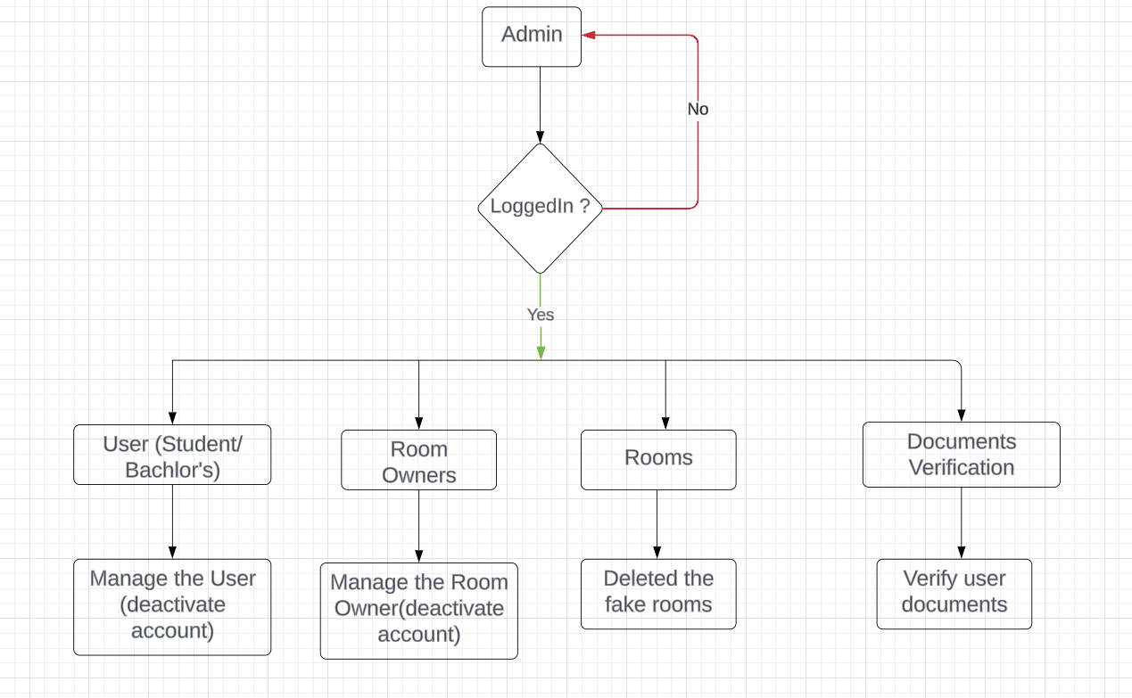

Figure 4. 1 Admin Login

* **User Management and Rule Enforcement**:

Admins have the authority to deactivate accounts of users (students and bachelors) who do not adhere to ApnaPG's rules and regulations. This includes behaviors such as repeated rule violations, fraudulent activities, or any actions that compromise the platform’s integrity. By actively monitoring user activities and addressing non-compliance, admins help maintain a respectful and orderly community.

* **Room Listing Verification and Fake Room Deletion**:

A key responsibility of admins is to verify the legitimacy of room listings. This involves scrutinizing the details provided by room owners to ensure accuracy and authenticity. Admins are tasked with deleting fake or misleading room listings to prevent fraud and protect prospective tenants from scams. This verification process is essential to uphold the platform's reputation and trustworthiness.

* **Document Verification**:

To enhance security and trust, admins verify the documents submitted by users and room owners. This may include identity verification for students and bachelors, as well as property documents from room owners. Through meticulous document checks, admins ensure that all participants on the platform are genuine and the accommodations listed are legitimate.

* **Verification of Government Documents**:

A crucial aspect of the verification process is the authentication of government-issued documents. For students and bachelors, admins check identification documents such as passports, national identity cards, or driver's licenses to confirm their identity. For property owners, verification extends to documents such as property deeds, tax receipts, and business licenses. These documents must be cross-checked with official government databases where possible to ensure their validity.

## 4.9 User Login

The user login process for the "Accommodation Solution for Students and Bachelors - ApnaPG" platform is designed to ensure a seamless and user-friendly experience. When a user (student or bachelor) accesses the ApnaPG platform, they are prompted to log in. The system first checks if the user is already registered. If the user is registered, they can proceed to log in by entering their email and password. If the user is not registered, they are redirected to the registration process where they need to provide their email, first name, last name, mobile number, birthdate, and password. Once these details are submitted, the user is successfully registered in the system.

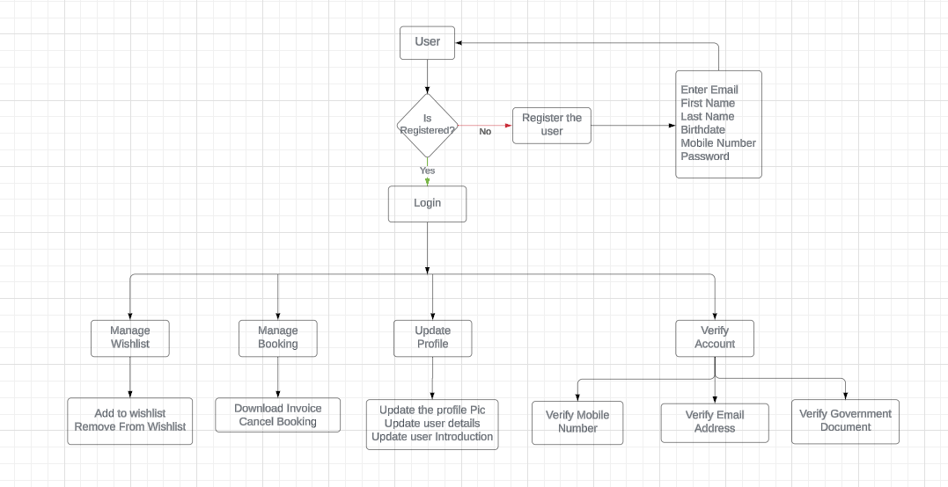

Figure 4. 2 User Login

Upon logging in, users are required to complete their profile by adding a profile picture and additional personal details. These details include their college name, favorite song, working company, current address, favorite pet animal, and a short introduction about themselves. This comprehensive profile helps in creating a more personalized experience on the platform.

Account verification is a crucial step in ensuring the authenticity and security of users on the platform. Users must verify their accounts through multiple steps: confirming their email address via a verification link sent to their email, entering a code sent to their mobile number, and uploading a government-issued document such as a PAN card, Aadhaar card, or passport. These verification steps help maintain the integrity and trustworthiness of the platform. Once logged in and verified, users can search for rooms that meet their specific requirements. They can book a room by selecting it and completing the payment process online. This streamlined booking process makes it easy for users to find and secure accommodation that fits their needs.Users also have the option to manage their bookings efficiently. They can download invoices for their bookings and cancel their bookings if needed. This functionality provides users with flexibility and control over their reservations.

Additionally, the platform allows users to manage their wishlist. Users can add rooms to their wishlist for future consideration and remove rooms from their wishlist if they no longer wish to consider them. This feature helps users keep track of their preferred accommodation options.

In summary, the ApnaPG platform offers a comprehensive and intuitive process for users, from registration and profile completion to account verification and room booking. The ability to manage bookings and wishlist further enhances the user experience, making it easier for students and bachelors to find and secure suitable accommodation.

## 4.10 Room Owner Login

The user login process for room owners on the "Accommodation Solution for Students and Bachelors - ApnaPG" platform is designed to provide a comprehensive set of features that cater to both their personal and professional needs. Similar to regular users, room owners begin by logging in using their email and password. If they are not registered, they are required to complete the registration process by providing essential details such as their email, first name, last name, mobile number, birthdate, and password. This ensures that only verified users can access the platform. Once logged in, room owners are prompted to complete their profiles with additional information.

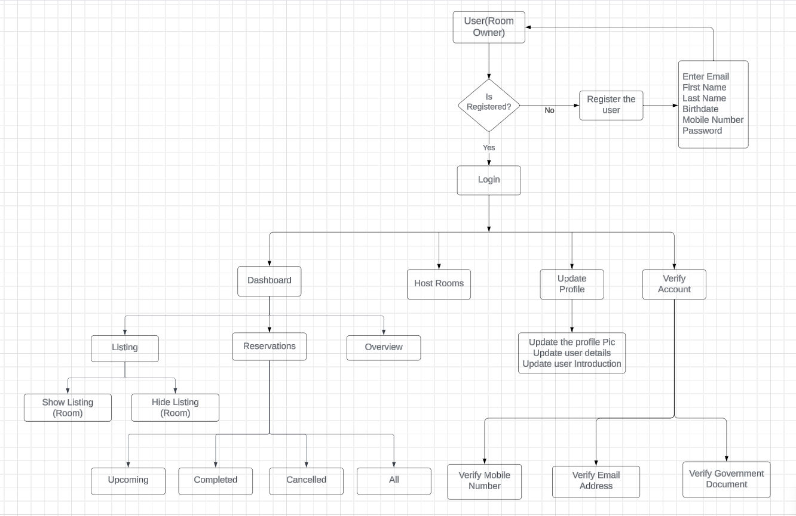

Figure 4. 3 Room owner login

This includes uploading a profile picture, and providing details about themselves such as their college name, favorite song, working company, current address, favorite pet animal, and a brief introduction. These details help in creating a more personalized and trustworthy profile. An important aspect of the room owner’s profile is the account verification process. Room owners must verify their email address, mobile number, and provide a government-issued document such as a PAN card, Aadhaar card, or passport. This multi-step verification process is crucial to ensure the security and authenticity of room owners on the platform. Room owners have access to a dedicated dashboard that provides an overview of their activities and listings. The dashboard features sections for managing reservations and listings. In the reservations section, room owners can view upcoming, completed, and cancelled bookings, as well as an overall view of all reservations. This allows them to keep track of their bookings and manage them efficiently. The platform also allows room owners to host rooms. They can list new rooms by providing detailed information about the accommodation, and they have the option to show or hide these listings on the platform. This feature provides room owners with the flexibility to control the visibility of their rooms based on availability or other factors.Additionally, room owners can update their profile information at any time. They can change their profile picture, update their personal details, and modify their introduction. This ensures that their profile remains current and accurate, which is important for building trust with potential tenants.

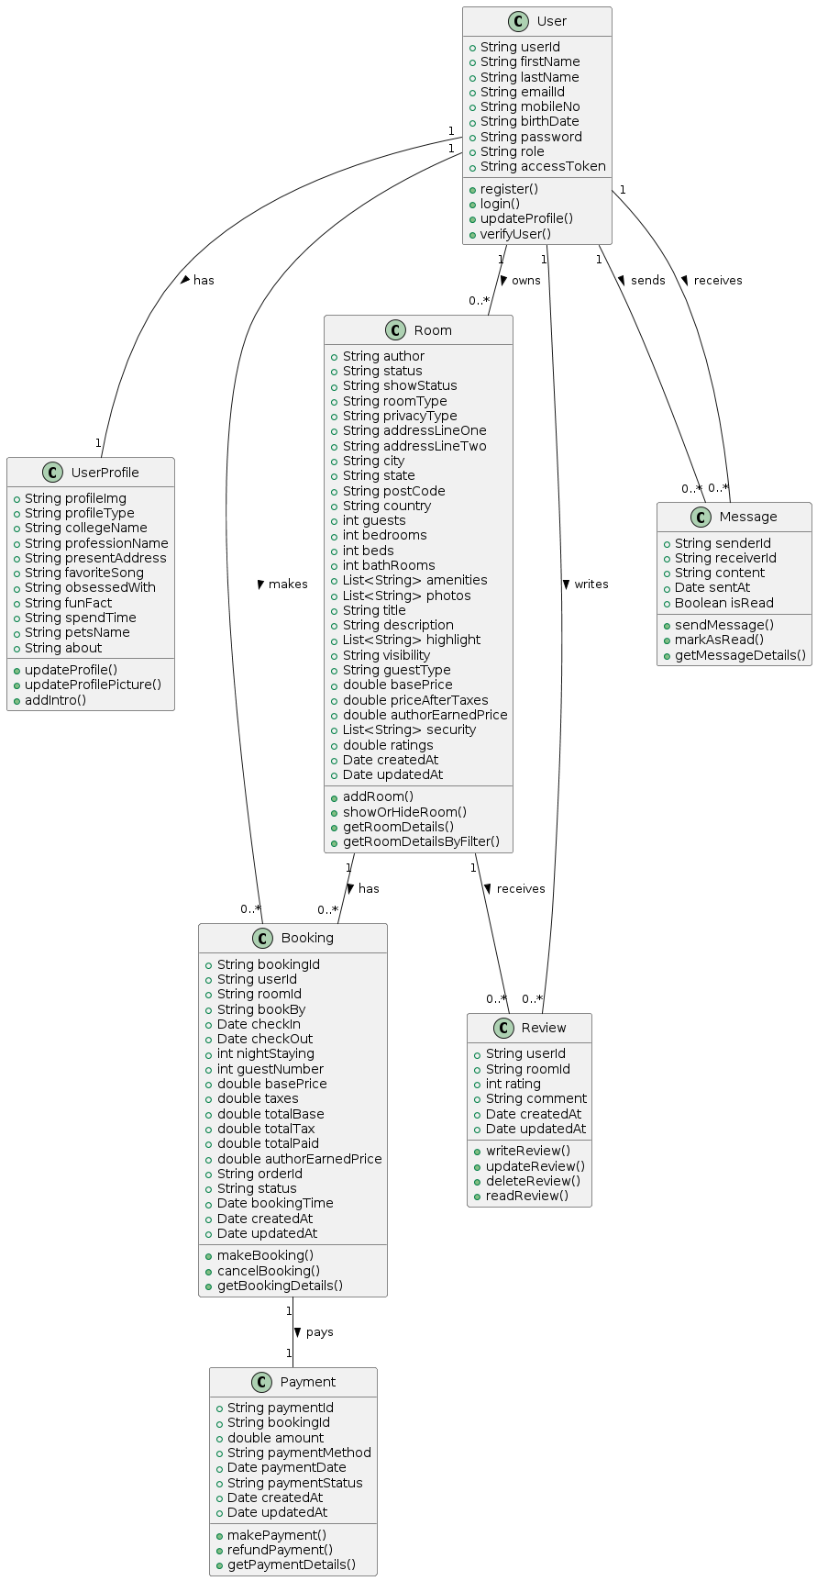

Figure 4. 4 Class diagram

This class diagram represents the structure and relationships between various entities in the "Accommodation Solution for Students and Bachelors - ApnaPG" platform. The main classes are User, UserProfile, Room, Booking, Payment, Message, and Review.

The User class contains attributes such as user ID, first name, last name, email, mobile number, birth date, password, role, and access token. It includes methods for user registration, login, profile updates, and verification. Each User has a UserProfile which holds additional details like profile image, profile type, college name, profession, address, favorite song, and more. Methods in UserProfile allow for updating the profile picture and introduction. The Room class, associated with the User, includes details about the room such as author, status, type, privacy, address, amenities, photos, title, description, visibility, guest type, base price, and ratings. Methods here handle adding, showing, hiding, and retrieving room details. The Booking class links to both User and Room, capturing booking details like booking ID, user ID, room ID, check-in and check-out dates, number of guests, price, order ID, and status. It includes methods for making, canceling, and retrieving bookings. Payments for bookings are handled by the Payment class, which records payment details like payment ID, booking ID, amount, method, date, and status, with methods for making, refunding, and retrieving payments.

Users can communicate via the Message class, which tracks the sender, receiver, content, and status of messages. Methods enable sending, marking as read, and retrieving message details.

Lastly, the Review class allows users to provide feedback on rooms with attributes for user ID, room ID, rating, comment, and timestamps. It includes methods for writing, updating, deleting, and reading reviews.

Overall, this class diagram outlines a comprehensive system for managing user interactions, room listings, bookings, payments, messaging, and reviews within the ApnaPG platform.

# Chapter 5

# IMPLEMENTATION

The "Accommodation Solution for Students and Bachelors - ApnaPG" project is a transformative platform aimed at revolutionizing the process of finding and managing accommodations for students and bachelors. In today's fast-paced world, where mobility and flexibility are paramount, the need for a seamless and efficient accommodation solution has never been more pressing. This project endeavors to address this need by leveraging cutting-edge technologies and innovative design principles to create a comprehensive and user-friendly platform.

## 5.1 Implementation of User Interface using React

Implementing the user interface (UI) for the "Accommodation Solution for Students and Bachelors - ApnaPG" project using React involves several key steps and best practices to ensure a seamless, efficient, and maintainable application. React, a powerful JavaScript library for building user interfaces, offers a component-based architecture that facilitates the development of reusable UI components.

* **Component-Based Architecture:**

The core of React is its component-based architecture. Each part of the UI is built as a component, which can be independently developed, tested, and reused. Components can be either functional or class-based, though functional components with hooks are now the standard due to their simplicity and the power of React hooks. The Figma design for the project is translated into a hierarchical structure of React components. For example, the main dashboard can be a component that includes child components like navigation bars, product listings, and user profile sections.

* **State Management:**

State management in React is crucial for maintaining the dynamic aspects of the UI, such as user interactions and data fetching. For this project, react-hook-form is utilized for efficient form handling and validation, providing a performant solution for managing user input. React-hook-form simplifies form state management and submission handling, offering a straightforward solution for handling user input.

* **React Router for Navigation:**

React Router is employed to manage navigation within the application. It allows for declarative routing, enabling dynamic routing based on the application's state. This ensures that users can navigate seamlessly between different pages, such as the product catalog, order history, and user settings, without refreshing the entire page. React Router’s <Route>, <Switch>, and <Link> components help define routes and navigation paths clearly, contributing to a smooth user experience.

* **Styling Components:**

Tailwind CSS is utilized for streamlined styling and responsive design, allowing for quick prototyping and easy customization of styles. Tailwind CSS enables quick and efficient styling, with utility-first classes for rapid development and customization. This approach keeps styles close to the components they affect, enhancing maintainability and readability.

* **API Integration:**

React components interact with the backend through API calls. For this project, Cloudinary integration is used for efficient image upload functionality, enhancing the user experience by allowing users to easily upload and manage accommodation images. API integration ensures that the UI reflects the latest data from the backend, providing a seamless experience for users.

* **Form Handling and Validation:**

Handling forms and user input is a common requirement in React applications. React-hook-form simplifies form state management and submission handling, while also providing efficient form validation. This integration ensures that forms are robust, user-friendly, and secure, enhancing the overall usability of the application.

* **Performance Optimization:**

Performance optimization is essential for delivering a fast and responsive user experience. React’s built-in features like React.memo and useMemo help prevent unnecessary re-renders by memoizing components and values. Additionally, lazy loading components with React.lazy and Suspense can defer the loading of parts of the UI until they are needed, improving initial load times.

* **Implementation of React:**

To set up the development environment, Node.js and npm (Node Package Manager) are required. Node.js is a JavaScript runtime that allows running JavaScript on the server side, and npm is a package manager that helps install and manage dependencies. After verifying the installation, Create React App is used to set up a new React project with Vite as the bundler. This simplifies the initial setup by providing a boilerplate structure and necessary configurations. The project directory is organized to keep it maintainable, with folders for components, pages, and assets. Reusable components are created based on the Figma design, ensuring a structured and modular UI. React Router is then set up for client-side routing, enabling seamless navigation between different pages.

## 5.2 Implementation of Backend using Node.js

Implementing the backend for the "Accommodation Solution for Students and Bachelors - ApnaPG" project using Node.js and Express involves setting up a robust and scalable server-side application.

**Technology Stack**:

* **Node.js with Express.js**: The backend is built using Node.js and Express.js, providing a robust and scalable server-side framework for handling HTTP requests.
* **MongoDB**: MongoDB serves as the primary database, offering flexibility and scalability for storing accommodation, user, and reservation data.
* **Cloudinary**: Cloudinary is used for efficient image storage and management, ensuring optimal performance for image-heavy applications.

**Key Features**:

* **RESTful API Development**: The backend provides a RESTful API for handling CRUD operations related to accommodations, users, and reservations, ensuring interoperability and scalability.
* **MongoDB Integration**: MongoDB is seamlessly integrated into the backend, offering schema flexibility and scalability to accommodate evolving data requirements.
* **Image Storage**: Cloudinary integration allows for efficient storage and management of accommodation images, ensuring optimal performance and scalability for image-heavy applications.

**4. Backend Implementation:**

Technology Stack:

* **Node.js with Express.js**: The backend is built using Node.js and Express.js, providing a robust and scalable server-side framework for handling HTTP requests.
* **MongoDB**: MongoDB serves as the primary database, offering flexibility and scalability for storing accommodation, user, and reservation data.
* **Cloudinary**: Cloudinary is used for efficient image storage and management, ensuring optimal performance for image-heavy applications.

**Key Features:**

* **RESTful API Development**: The backend provides a RESTful API for handling CRUD operations related to accommodations, users, and reservations, ensuring interoperability and scalability.
* **MongoDB Integration**: MongoDB is seamlessly integrated into the backend, offering schema flexibility and scalability to accommodate evolving data requirements.
* **Image Storage:** Cloudinary integration allows for efficient storage and management of accommodation images, ensuring optimal performance and scalability for image-heavy applications.

## 5.3 Implementation for Database Layer

**Technology Stack**:

MongoDB: MongoDB serves as the database layer, providing schema-less document-based data storage for accommodations, users, and reservations.

**Key Features**:

* **Schema Design**: MongoDB schemas are carefully designed to reflect the structure of accommodation, user, and reservation data, ensuring consistency and integrity.
* **Relationships**: Relationships between entities are established using MongoDB's embedding and referencing mechanisms, enabling efficient data retrieval and management.
* **Indexing**: Proper indexing strategies are implemented to optimize query performance, ensuring fast and efficient data access.

**DevOps and Deployment:**

* **Development Environment**: Vite and Nodemon are used for frontend and backend development, respectively, providing fast builds and hot module replacement for an efficient development workflow.
* **Version Control**: Git is utilized for source code management, allowing for collaboration, versioning, and tracking of changes throughout the development lifecycle.
* **Deployment**: The application can be deployed using platforms like Netlify or Vercel for the frontend and services like Heroku or AWS for the backend, ensuring seamless hosting and scalability to meet the demands of users.

## 5.4 Integration of Nodemailer

In general, a mail and SMS sender is a software application that allows you to send email messages and SMS text messages to one or more recipients [4]. These types of applications are commonly used for a variety of purposes, such as marketing campaigns, customer service, and personal communication. When sending email messages and SMS text messages, it is important to ensure that the sender is authorized to send messages on behalf of the organization or individual. To better communication between the user and system mail and SMS service is very important for customer satisfaction purposes.

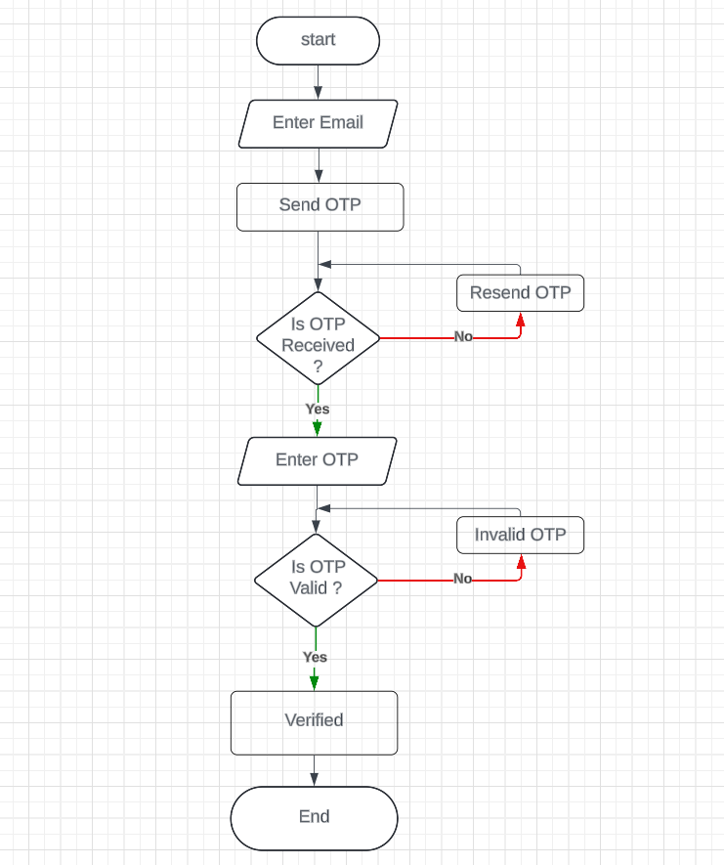

Figure 4. 5 Send Email

Nodemailer is a Node.js module that simplifies the process of sending emails from server-side applications. It offers an intuitive interface and powerful capabilities, making it an essential tool for communication tasks. Integration of nodemailer into Node.js applications involves several key steps.

Firstly, developers install nodemailer using npm, the Node.js package manager. With a simple npm command, developers can add nodemailer to their project dependencies, enabling seamless integration. Next, developers configure nodemailer by creating a transporter object. This transporter encapsulates the email service provider details, including the SMTP server address, port number, and authentication credentials. By specifying the service provider (e.g., Gmail, Outlook) and providing authentication details, developers establish a connection to the email server. Once the transporter is set up, developers define mail options. These options include essential email details such as the sender's email address, recipient's email address, subject line, and email body content. Additionally, developers can customize emails by including HTML content, attachments, and inline images. Finally, developers use the transporter's sendMail() method to send the email. By passing the defined mail options to this method, nodemailer initiates the email sending process. Developers can handle any errors or receive confirmation of successful email delivery through a callback function.

Overall, nodemailer simplifies email integration in Node.js applications, offering a streamlined approach to sending transactional emails. With its intuitive interface and robust features, nodemailer empowers developers to enhance their applications with efficient email communication capabilities.

**Installation**

Nodemailer is a powerful and easy-to-use Node.js module that facilitates email sending from server-side applications. It simplifies the process of integrating email functionalities into your application, enabling seamless communication with users. Here’s a concise guide on how to integrate Nodemailer into a Node.js application:

**Installation**

To begin with, install Nodemailer using npm, the Node.js package manager. Run the following command in your project directory:

npm install nodemailer

This command adds Nodemailer to your project dependencies, making it available for use in your application.

**Configuration**

Next, configure Nodemailer by creating a transporter object. This object contains the necessary details to connect to your email service provider. Here’s an example configuration for using Gmail as the email service:

const nodemailer = require('nodemailer');

let transporter = nodemailer.createTransport({

service: 'gmail',

auth: {

user: 'your-email@gmail.com',

pass: 'your-email-password'

}

});

In this configuration, service specifies the email provider, and auth contains the authentication credentials (email and password).

**Defining Mail Options**

Once the transporter is set up, define the mail options. These options specify the email’s details, including the sender, recipient, subject, and body content:

let mailOptions = {

from: 'your-email@gmail.com',

to: 'recipient-email@example.com',

subject: 'Test Email',

text: 'Hello, this is a test email from Node.js using Nodemailer!'

};

You can customize these options further by including HTML content, attachments, or inline images.

**Sending the Email**

Finally, use the transporter's sendMail() method to send the email. Pass the mail options to this method and handle the response to confirm email delivery or catch any errors:

transporter.sendMail(mailOptions, (error, info) => {

if (error) {

return console.log(error);

}

console.log('Email sent: ' + info.response);

});

This method initiates the email sending process, and the callback function allows you to manage success or failure responses effectively.

Integrating Nodemailer into a Node.js application is straightforward and enhances your application’s communication capabilities. By following these steps—installing Nodemailer, configuring the transporter, defining mail options, and sending the email—you can efficiently send emails from your Node.js server, supporting a wide range of use cases from transactional notifications to user interactions.

## 5.5 Integration of Twilio

Twilio is a robust cloud communication platform that provides APIs for sending and receiving SMS messages, making it easy to integrate SMS functionalities into your Node.js applications. Twilio is a cloud-based communication platform that provides a suite of APIs and tools for building voice, video, messaging, and authentication applications. Integrating Twilio into Node.js applications enables developers to leverage its powerful communication capabilities.

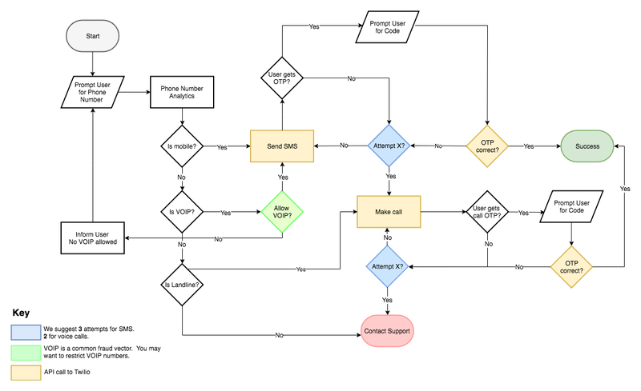

Figure 4. 6 Send SMS

To integrate Twilio, developers first create a Twilio account and obtain authentication credentials, including an Account SID and Auth Token. These credentials authenticate requests made to Twilio's REST API, ensuring secure communication between the Node.js application and Twilio's servers. Next, developers install the Twilio Node.js SDK using npm. This SDK simplifies interaction with Twilio's REST API, providing convenient methods for sending messages, making calls, and verifying user identities. Developers can then use Twilio's Messaging API to send SMS messages and multimedia messages (MMS) directly from their Node.js application. By invoking Twilio's messages.create() method with the appropriate parameters, developers can initiate outbound messaging operations seamlessly. Similarly, developers can leverage Twilio's Voice API to make outgoing calls and handle incoming calls programmatically. Using Twilio's calls.create() method, developers can specify call details such as the caller ID, recipient's phone number, and TwiML instructions to orchestrate voice communication flows. Additionally, Twilio's Verify API facilitates user authentication and phone number verification processes. Developers can use Twilio's verify.services.create() method to initiate verification requests, prompting users to confirm their phone numbers via SMS or voice calls. By integrating Twilio into Node.js applications, developers unlock a wide range of communication possibilities, enabling innovative solutions for customer engagement, authentication, notification systems, and more. Twilio's versatility and developer-friendly APIs empower developers to build robust communication solutions tailored to their specific use cases.

**Installation**

First, install the Twilio Node.js SDK using npm. Run the following command in your project directory:

npm install twilio

This command adds the Twilio SDK to your project dependencies, enabling you to use Twilio's services in your application.

**Configuration**

Next, configure Twilio by creating a client object with your Twilio Account SID and Auth Token. These credentials are available in your Twilio console.

const twilio = require('twilio');

const accountSid = 'your_account_sid';

const authToken = 'your_auth_token';

const client = new twilio(accountSid, authToken);

Replace 'your_account_sid' and 'your_auth_token' with your actual Twilio credentials.

**Sending an SMS**

With the client configured, you can send an SMS by calling the client.messages.create() method. This method requires parameters such as the sender’s phone number, recipient’s phone number, and the message body:

client.messages.create({

body: 'Hello, this is a test message from Node.js using Twilio!',

from: '+1234567890', // Your Twilio phone number

to: '+0987654321' // Recipient's phone number

})

.then(message => console.log(message.sid))

.catch(error => console.log(error));

In this code, body contains the text message, from is your Twilio phone number, and to is the recipient’s phone number. The then method handles the response, logging the message SID if successful, while the catch method logs any errors.

**Handling Responses**

Twilio provides comprehensive feedback for sent messages, which you can use to manage your application’s flow. The then method in the example above captures the message SID, which uniquely identifies the sent message and can be used for tracking:

client.messages.create({

body: 'Hello, this is a test message from Node.js using Twilio!',

from: '+1234567890',

to: '+0987654321'

})

.then(message => {

console.log('Message sent with SID: ' + message.sid);

})

.catch(error => {

console.error('Error sending message: ', error);

});

Integrating Twilio into a Node.js application is straightforward and enables powerful SMS communication capabilities. By following these steps—installing the Twilio SDK, configuring the client, sending an SMS, and handling responses—you can efficiently send SMS messages from your Node.js server, supporting a wide range of use cases from alerts and notifications to two-factor authentication.

## 5.6 User document verification

In the ApnaPG platform, document verification is essential for ensuring the authenticity and accuracy of user-submitted documents such as Aadhaar card, PAN card, and passport. This process enhances security and builds trust within the community. When users provide their documents, the system compares the information on these documents with the user’s details already stored in the system, which include first name, last name, birthdate, and profile picture. The verification process starts with users uploading their government-issued documents. The system extracts the relevant data from these documents and cross-references it with the user’s registered details. Specifically, the first name, last name, birthdate, and profile picture on the document are compared with those in the user's profile. Advanced technologies like Optical Character Recognition (OCR) are employed to accurately read and extract information from the documents.

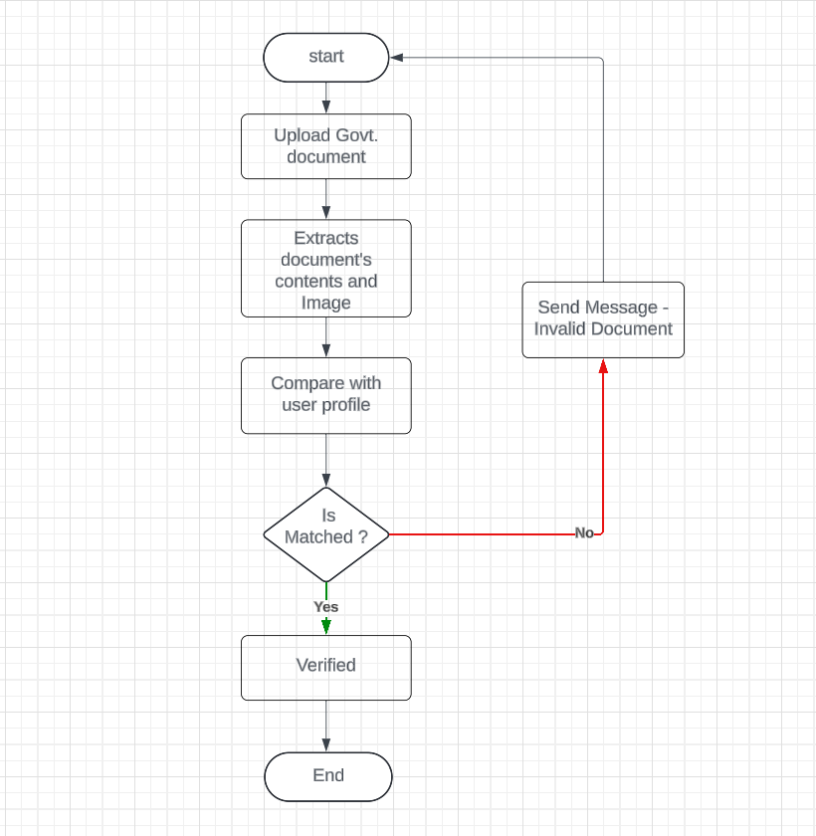

Figure 4. 7 Document verification

If the details on the document match the user’s profile information, the document is marked as verified. If there are discrepancies or if the document appears tampered with, the verification process flags the issue for further review, possibly involving a manual check by trained personnel. This robust document verification process ensures that only genuine users and property listings are present on the platform. It protects against fraud and identity theft, upholding the integrity and trustworthiness of the ApnaPG community.

The "Accommodation Solution for Students and Bachelors - ApnaPG" project utilizes a robust technology stack including Node.js, Express.js, MongoDB, Cloudinary, and React.js with Vite to offer a user-friendly platform for finding and managing accommodations. With RESTful API development, MongoDB integration, and Cloudinary for image storage, the backend ensures scalability and performance. On the frontend, React.js and Tailwind CSS create a responsive interface, enhancing the user experience. Overall, ApnaPG aims to revolutionize accommodation search with its efficient architecture and seamless deployment options.

# Chapter 6:

# RESULT AND DISCUSSION

The "Result and Discussion" section presents the implementation outcomes of the ApnaPG platform, showcasing its functionality and user experience through detailed screenshots. This section highlights the platform's key features, including user registration, accommodation search, booking process, and admin verification, emphasizing the effectiveness and user-friendliness of the solution.

## 6.1 Web app user interface

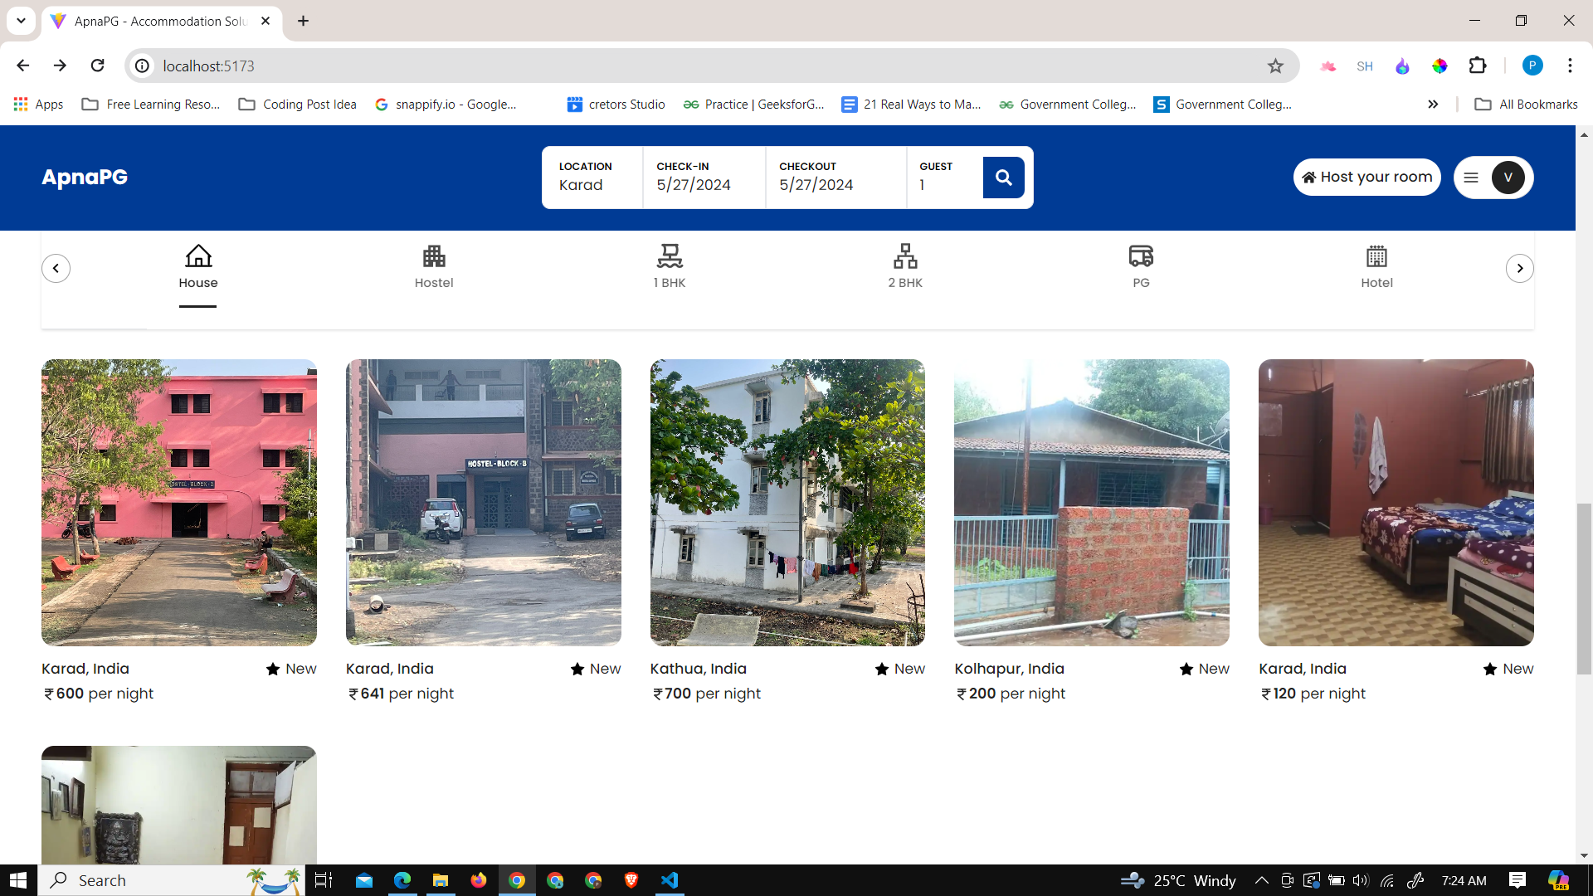

Figure 6. 1 ApnaPG Home Page

The ApnaPG home page is designed to provide a seamless and efficient user experience for individuals searching for accommodation. At the top of the page, a prominently placed search bar allows users to enter key details such as location, check-in date, check-out date, and the number of guests. Below the search bar, users can filter accommodations by type, including house, hostel, hotel, 1BHK, 2BHK, and PG, helping them narrow down options according to their preferences.

The main section of the home page displays a comprehensive listing of available rooms, complete with images, descriptions, pricing, and availability for easy comparison. Additionally, the home page features a user menu for account access and a login option for user authentication. For property owners, there is a "Host a Room" feature, enabling them to list their properties on the platform efficiently.

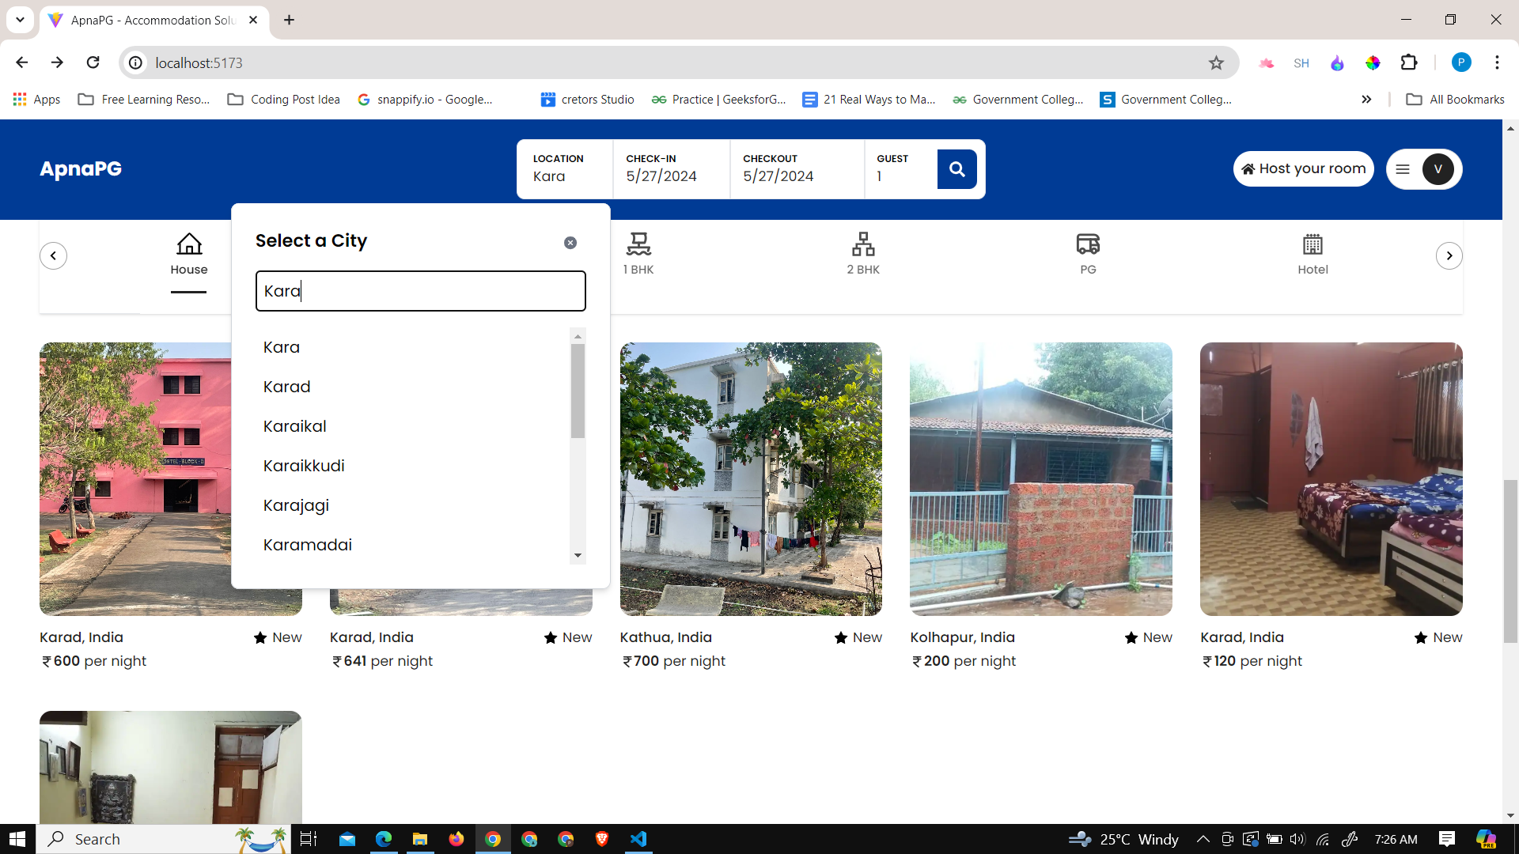

Figure 6. 2 Search the rooms

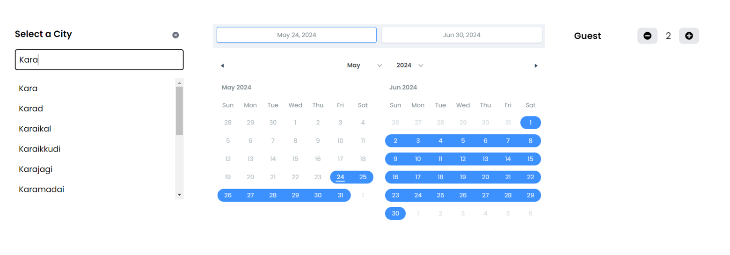

Figure 6. 3 Search the room based on location, check In, checkout, Guest Number

The ApnaPG platform offers an intuitive room search feature where users can easily find accommodations by entering the location, check-in date, check-out date, and the number of guests. The system automatically filters results based on the entered location and prevents the selection of past dates for check-in, ensuring accurate and up-to-date availability. This streamlined search process helps users quickly find suitable rooms that match their specific criteria.

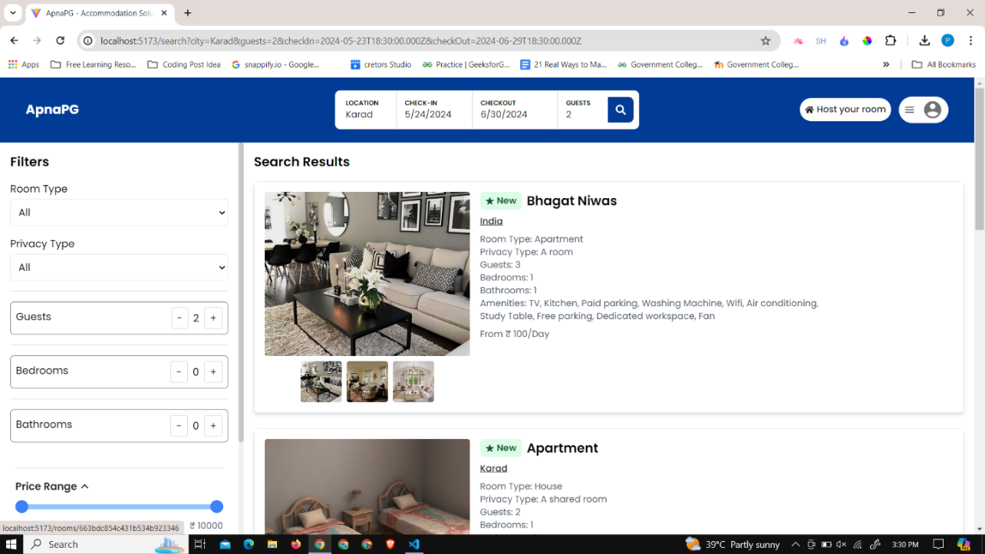

Figure 6. 4 Search page result

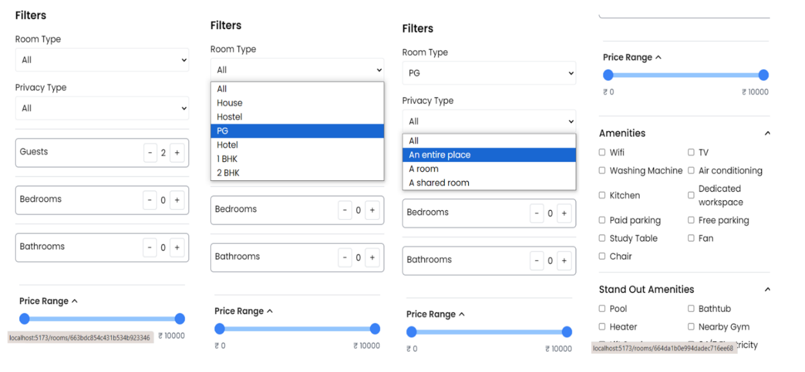

Figure 6. 5 Advanced filter options

The images above show the function of filters which can be used by the user to satisfy their demand with respect to all the available options provided in the accommodation spaces. This may include:

* **Room type**: house, hostel, PG, 1bhk, 2bhk.
* **Privacy type**: Entire place, room, shared room.
* **Amenities**: Fan, chair, WiFi, study table, etc.

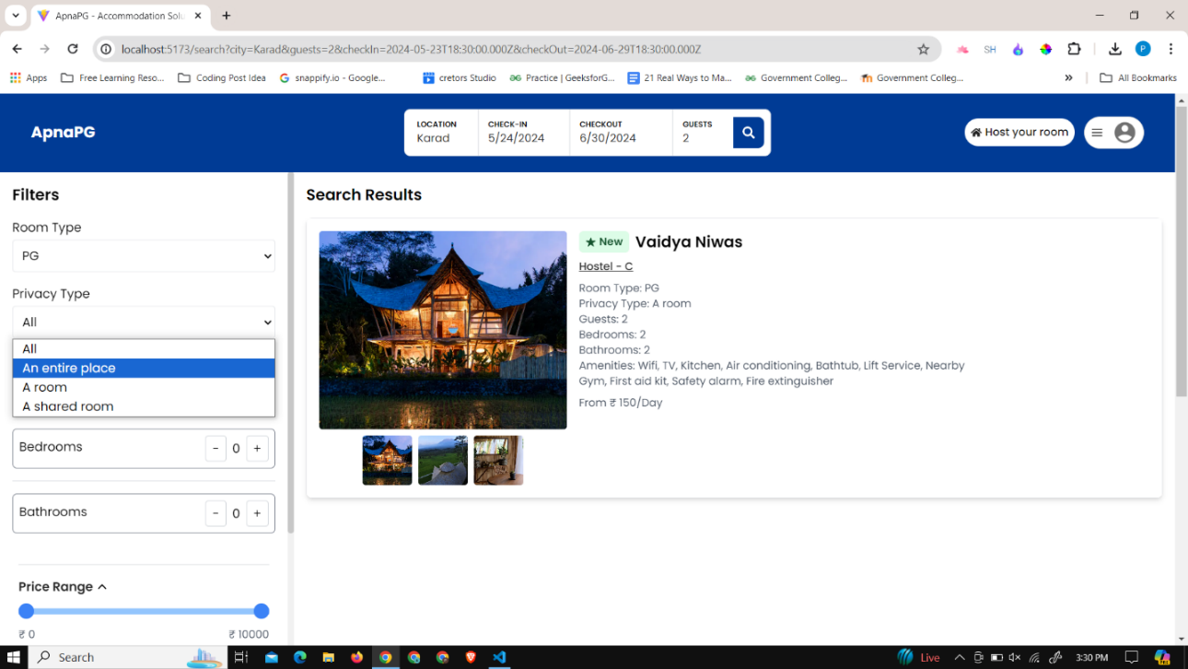

Figure 6. 6 User desired accommodation

The above image shows the result of applying all the filters desired by the user and may satisfy their needs.

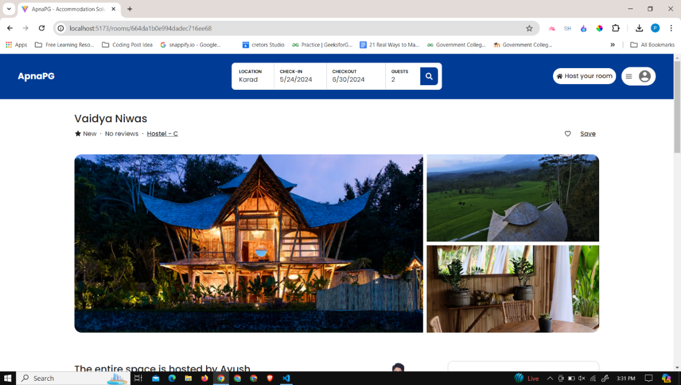

Figure 6. 7 Room details with the Title, location, images and save to Wishlist

The above image shows the detailed description of the room which includes the name of the accommodation, location and the room images, and gives the functionality to add to the Wishlist.

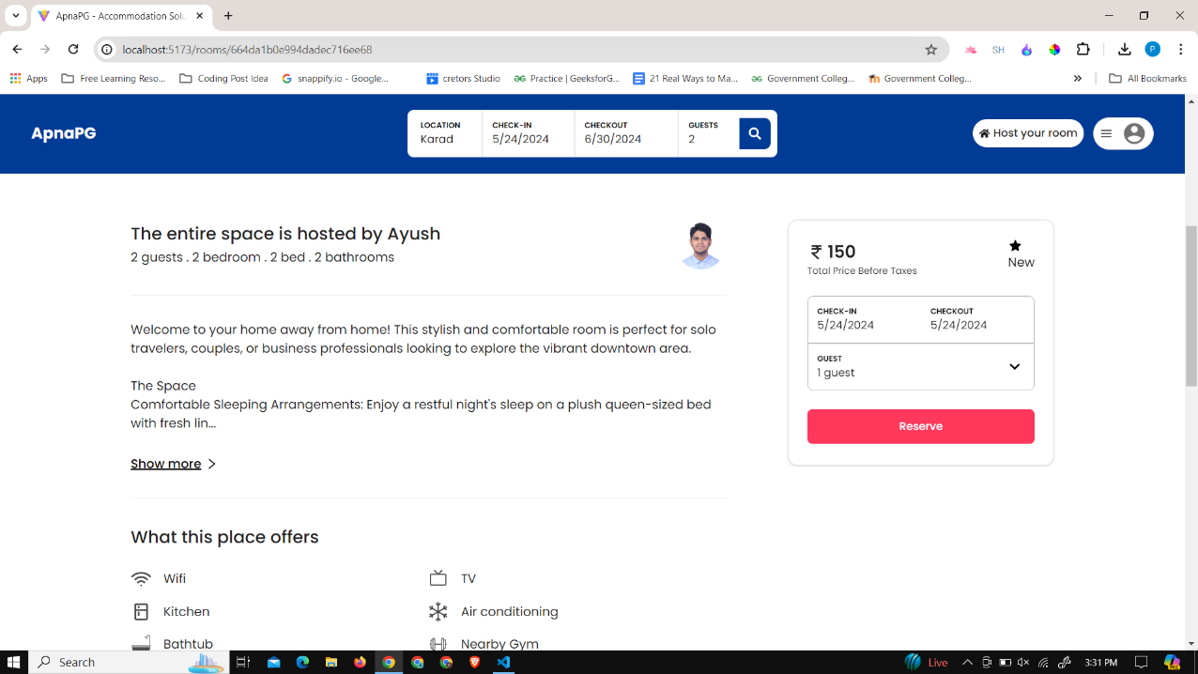

Figure 6. 8 Room details floorplan, description and amenities

The above image shows the detailed description of the room, it provides the description that includes the description of the accommodation, the amenities and the floor plan which includes number of the guest, number of the bedrooms and number of the bathrooms.

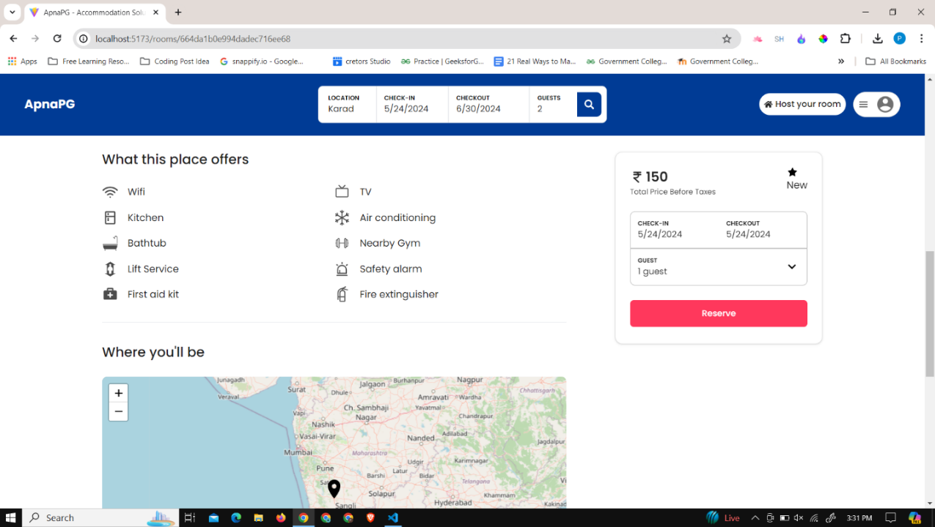

Figure 6. 9 Room details with location on map and booking card

This image shows the exactly where the accommodation is located, under which the user is able to schedule for how long they intent to stay. The user is presented with a payment option where the price of accommodation is set according to the number of days and number of guests.

## 6.2 User Registration and profile creation

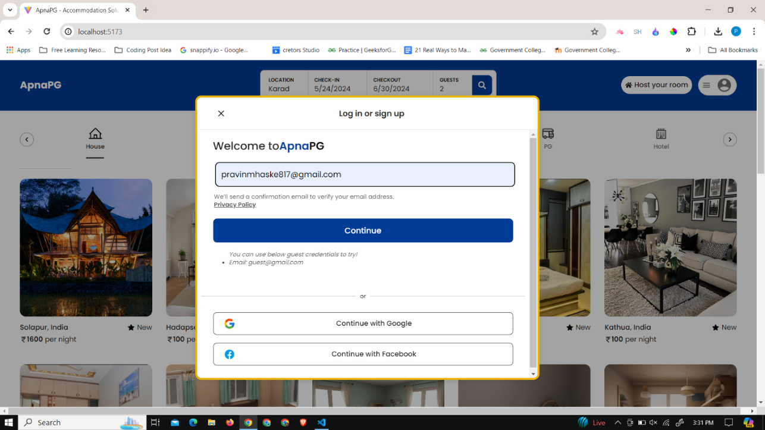

Figure 6. 10 User registration by entering the email address

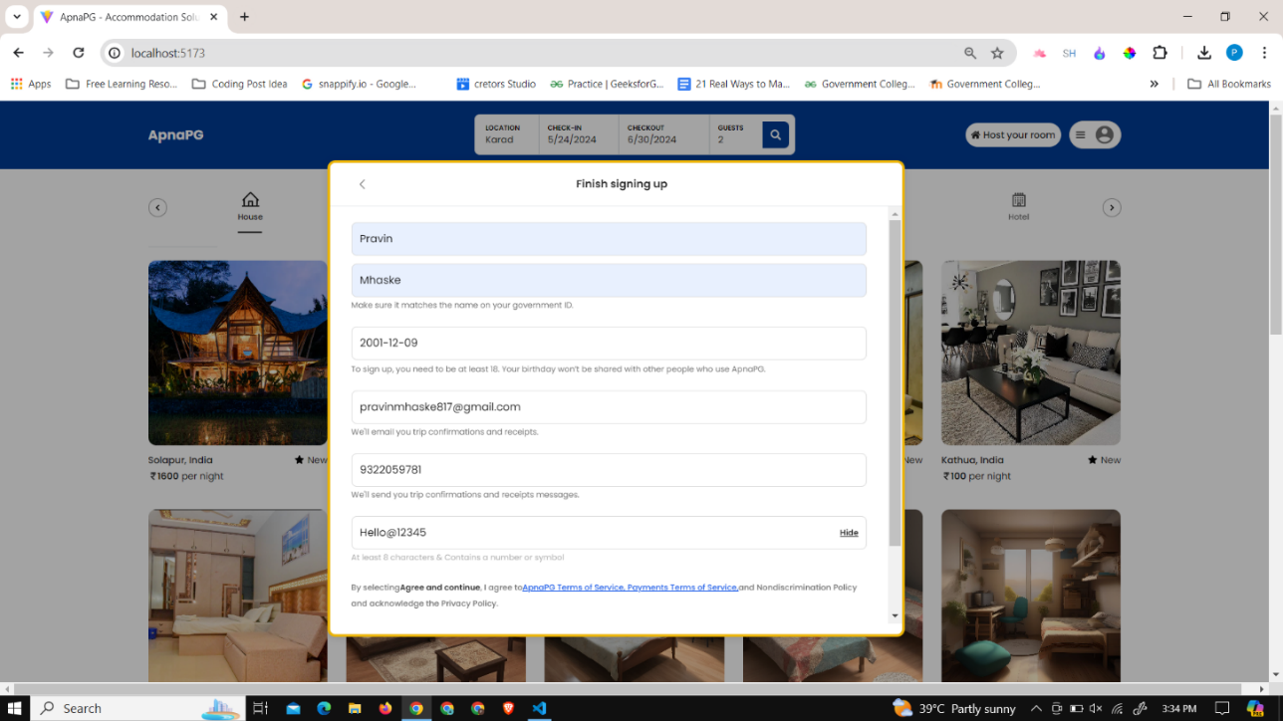

Figure 6. 11 User details such as name, mobile number, birthdate, password

In this image, the user is prompted to sign up or log in. When creating an account, the user is required to provide their name, birthdate, mobile number, and password. If the user is already registered, they are asked to log in with their credentials. Upon successful login, users can access additional features, manage their profile, and receive personalized accommodation recommendations based on their provided information. This ensures a tailored and efficient search experience.

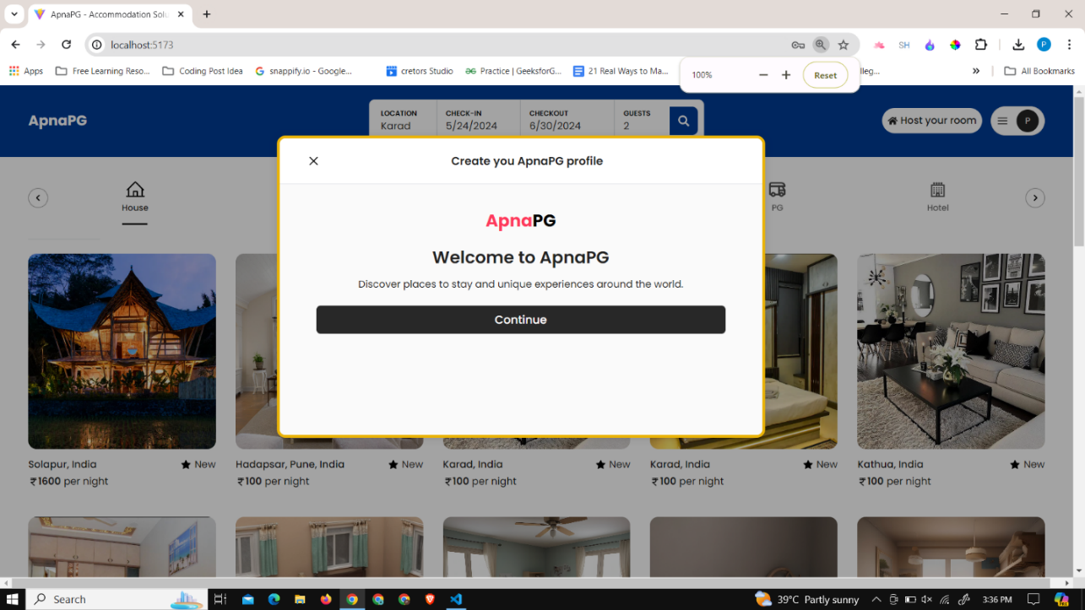

Figure 6. 12 Popup showing the create user profile

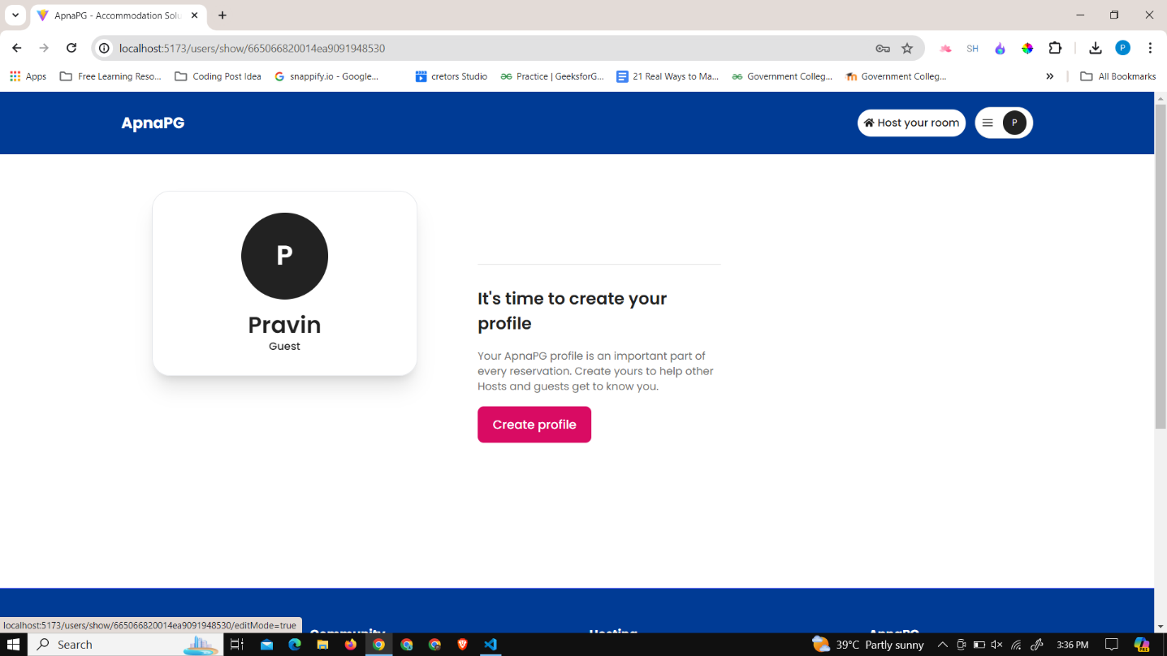

Figure 6. 13 Create the User profile redirection

After creating the account of the user, the user is redirected to a new page where they make their profile. The user has to mention their likes and dislikes and about themselves, such as their taste in music, what kind of person they are, hobbies, and other personal things. This helps them to match better and enhance the experience more.

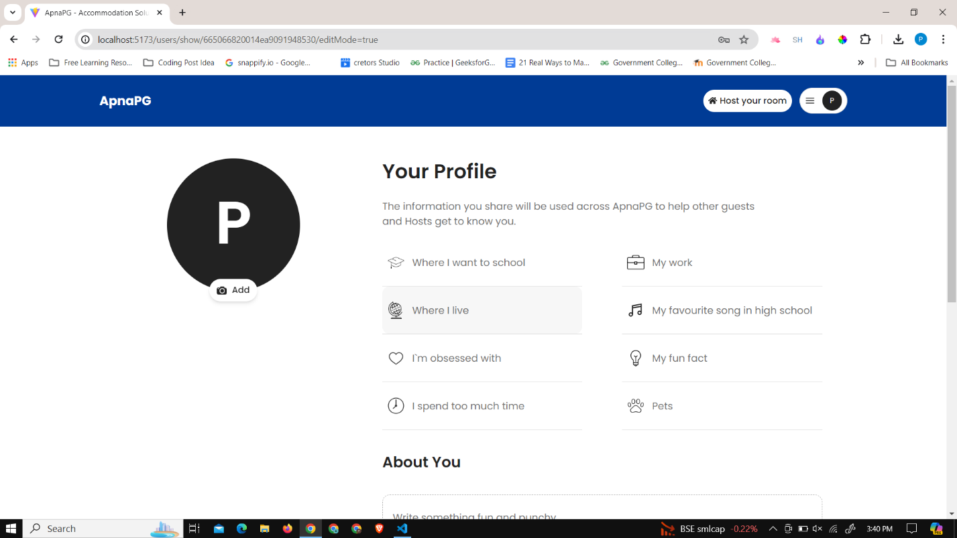

Figure 6. 14 Create the user profile

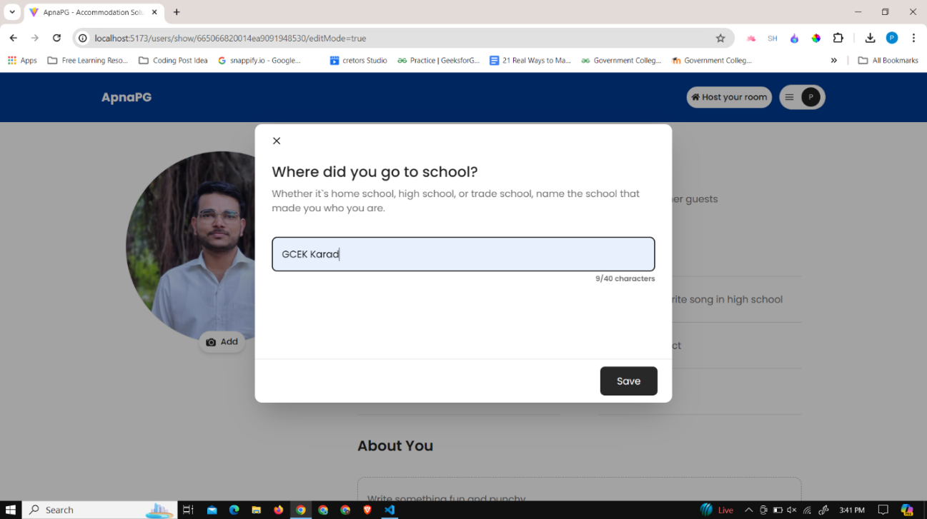

Figure 6. 15 Add the respective details in the fields

After creating their account, users are redirected to a profile creation page where they provide detailed personal information, including their school or college name, current workplace, and current address. Additionally, users share their favorite music, a fun fact about themselves, and how they spend their free time. This comprehensive profile helps match users with suitable accommodations and potential roommates, enhancing their overall experience on the ApnaPG platform.

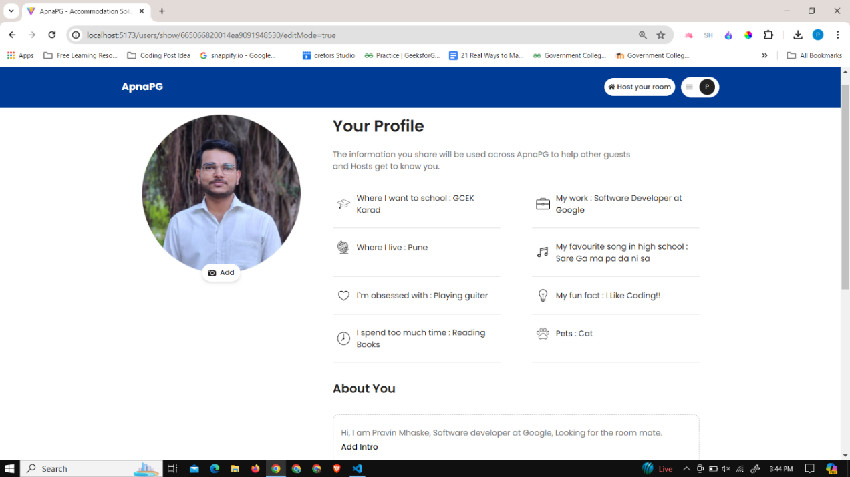

Figure 6. 16 Enter all the required details to create the profile and save changes

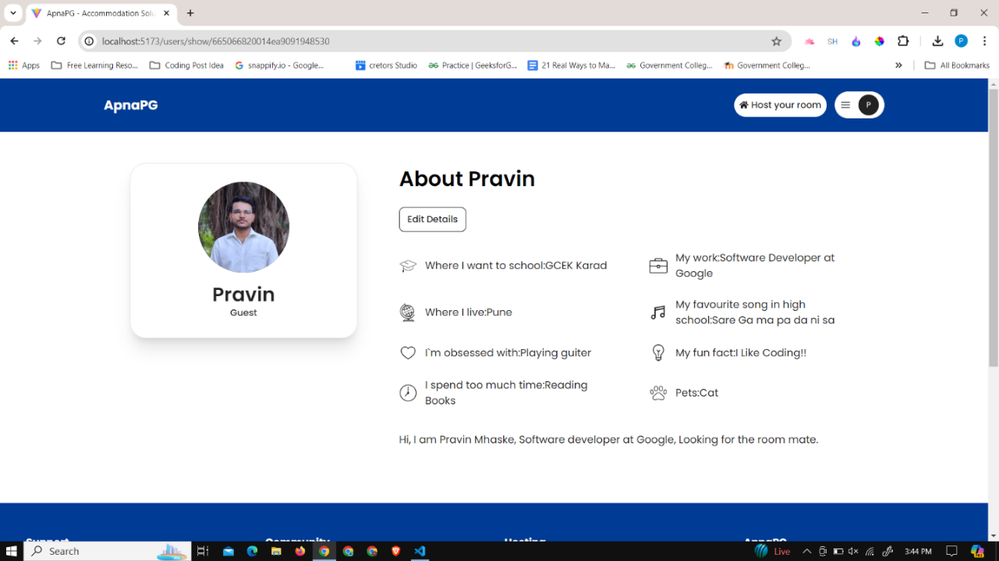

Figure 6. 17 Complete user profile page, user can edit the user profile

The necessary details of the user are filled and shown when the user clicks on their profile, with the profile picture and a small description of the user that may include an attractive punchy intro or small basic description about the person. The user may fill about their personality such as what songs they like the most, do they own a pet?, where did they study or graduate from? and some punchy fun fact about them.

## 6.3 User account verification

Once the profile is completed, ApnaPG requires both homeowners (or lenders) and customers (students or bachelors) to verify their identities. This verification process includes confirming their contact number, email address, and providing an official government ID, such as a passport, Aadhaar card, or PAN card. This step is crucial for ensuring the credibility and trustworthiness of all users on the platform.

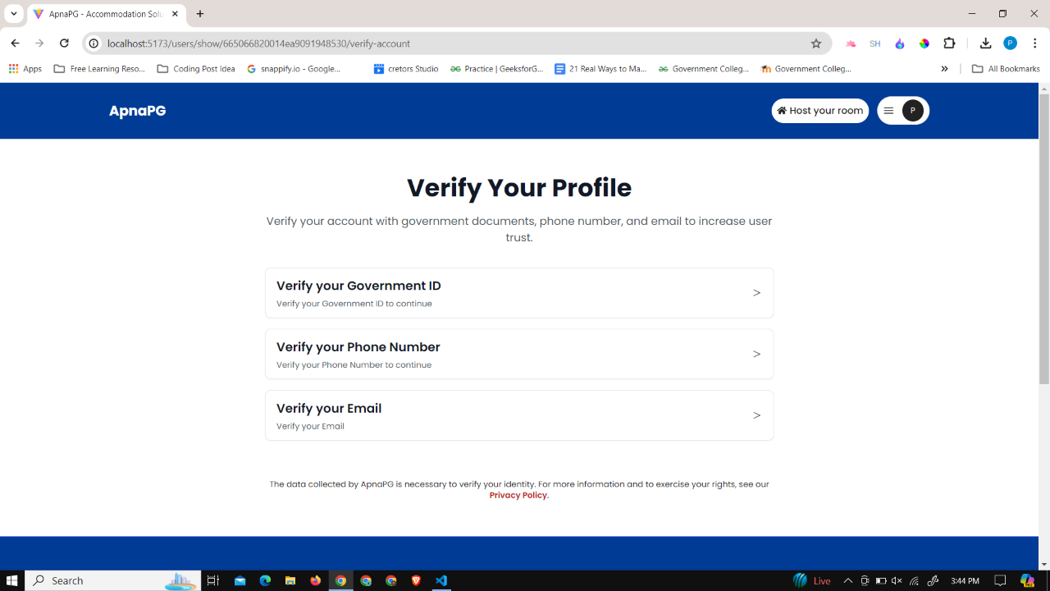

Figure 6. 18 User account verification

Email Verification:

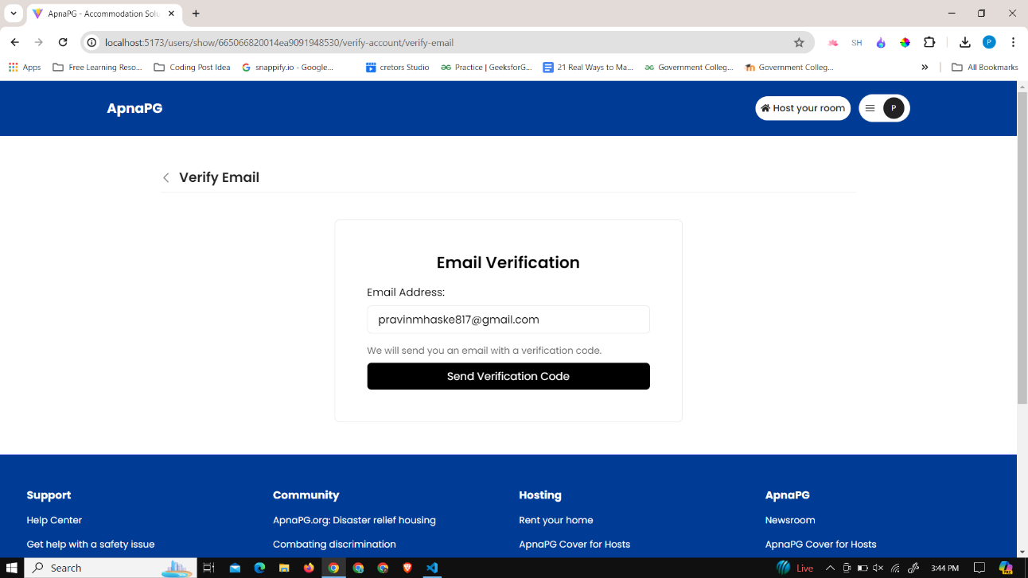

Figure 6. 19 User account verification with email ID

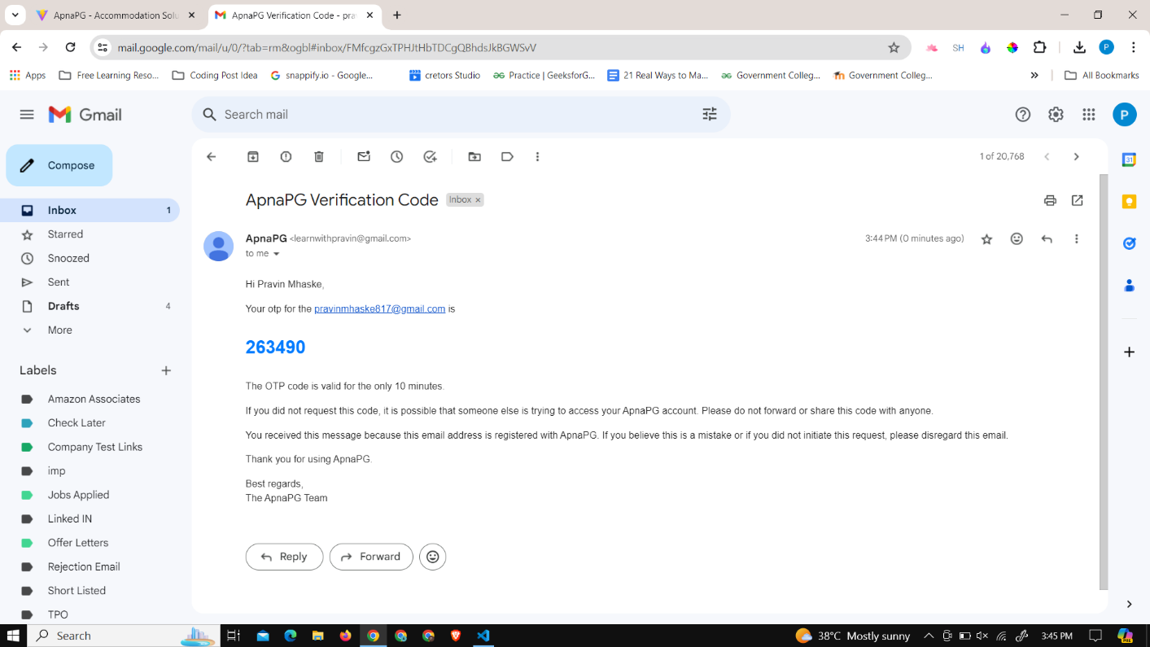

Figure 6. 20 User account verification Email Id OTP code on registered email

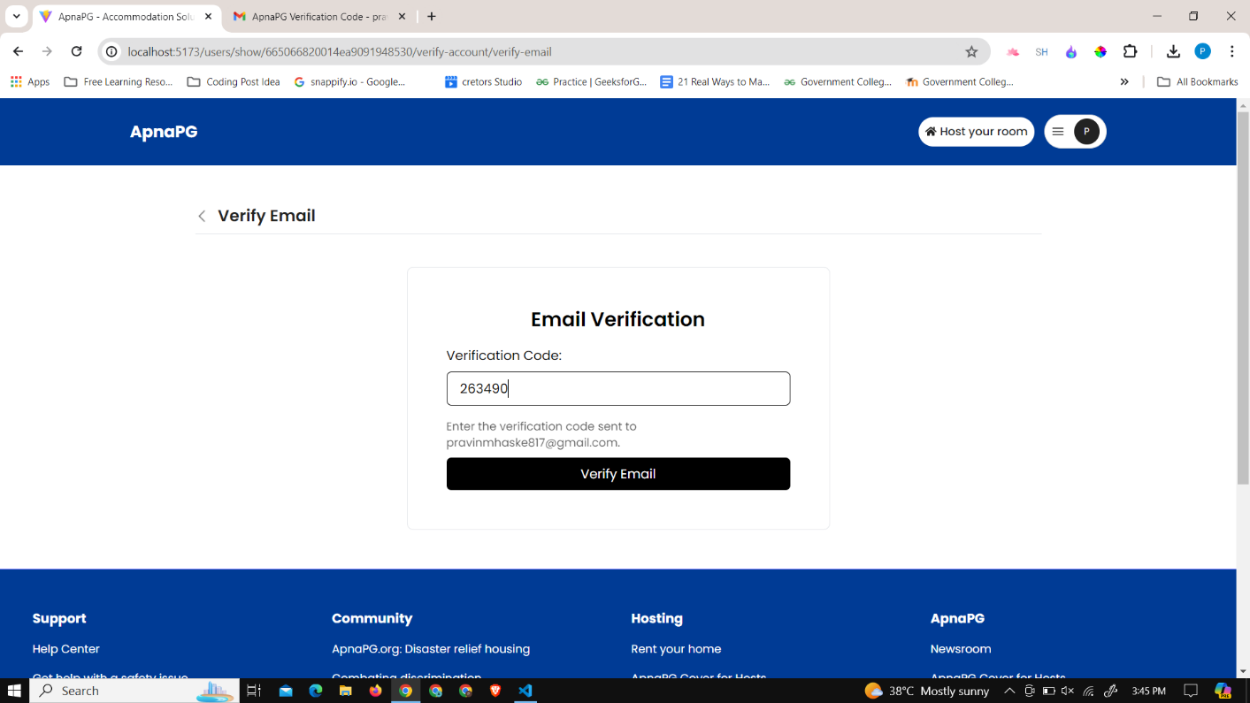

Figure 6. 21 Enter the user account email verification OTP code

The email is retrieved from the database when the user verifies their email by entering it in the verification panel. Once the user provides their email, a corresponding OTP (One Time Password) is sent to that email. The user must enter this OTP to complete the verification process. This helps eliminate insecurity for the user and prevents fake bot activity.

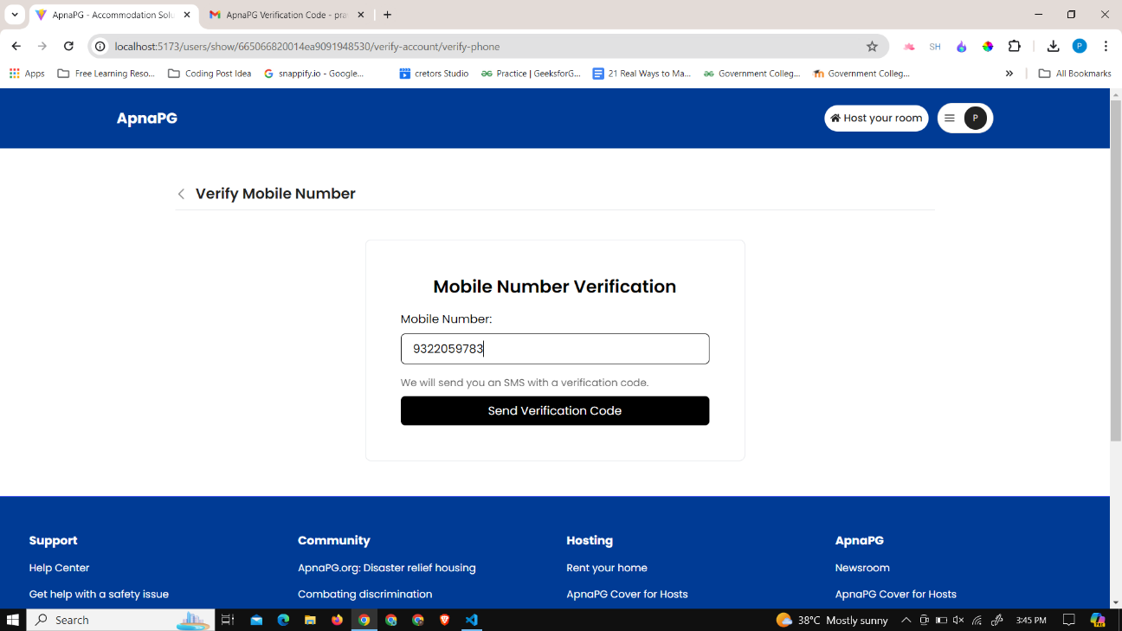

Figure 6. 22 User account mobile number verification

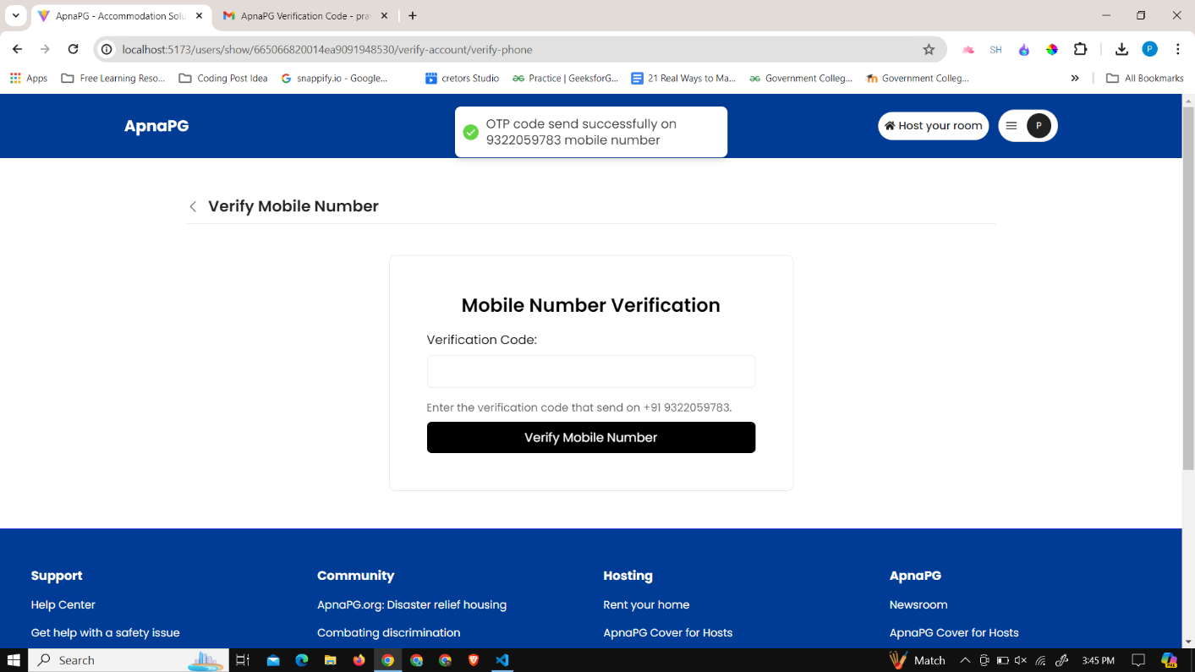

Figure 6. 23 Verification code for the mobile number verification

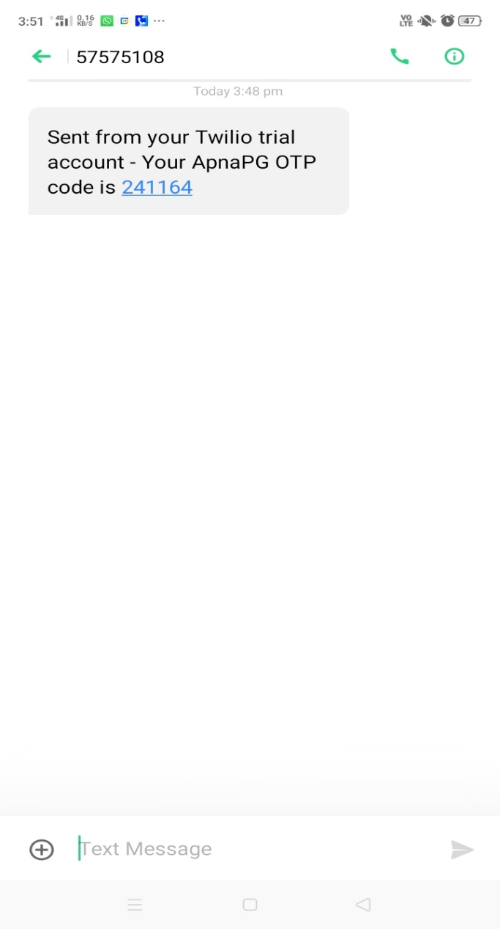

Figure 6. 24 Mobile verification OTP code

The phone number is retrieved from the database when the user verifies their phone number by entering it in the verification panel. Once the user provides their phone number, a corresponding OTP (One Time Password) is sent to that number. The user must enter this OTP to complete the verification process. This helps eliminate insecurity for the user and prevents fake bot activity.

Government Document verification

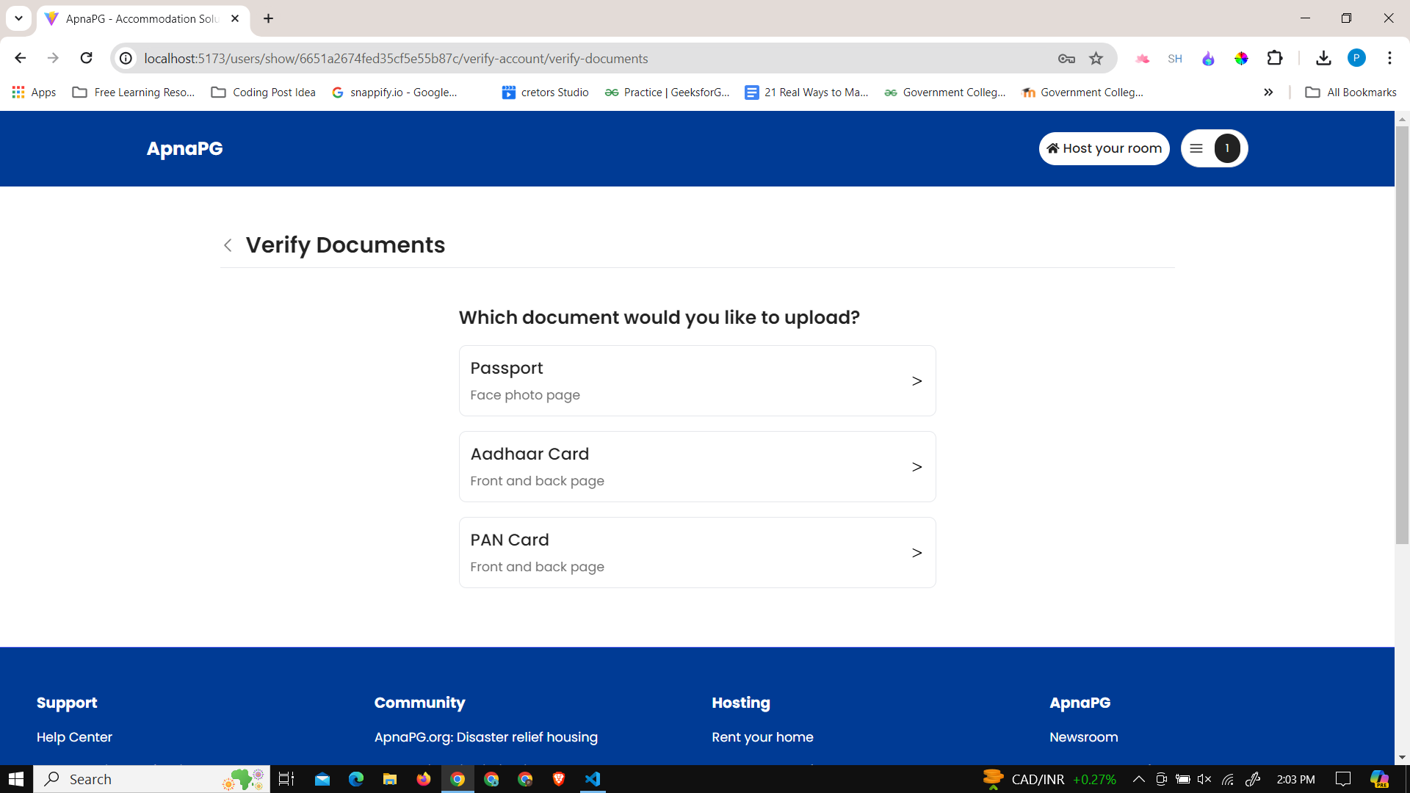

Figure 6. 25 Choose the government document to be verified

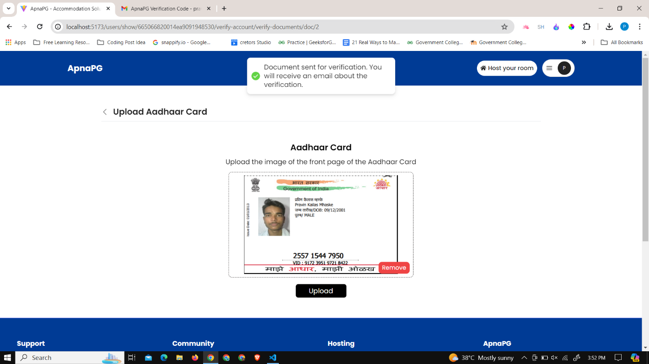

Figure 6. 26 Upload document for verification

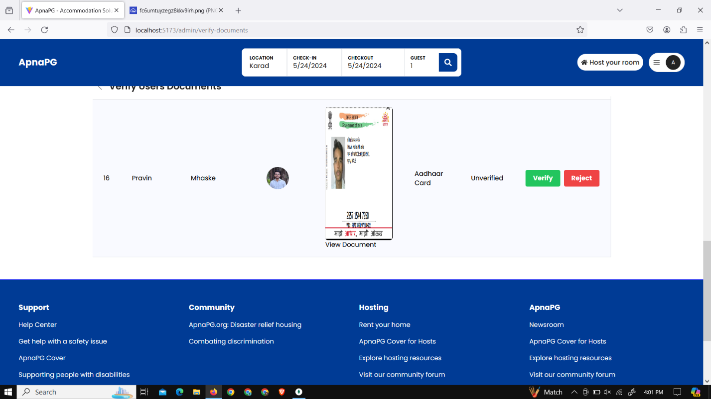

Figure 6. 27 Admin login to verify the documents

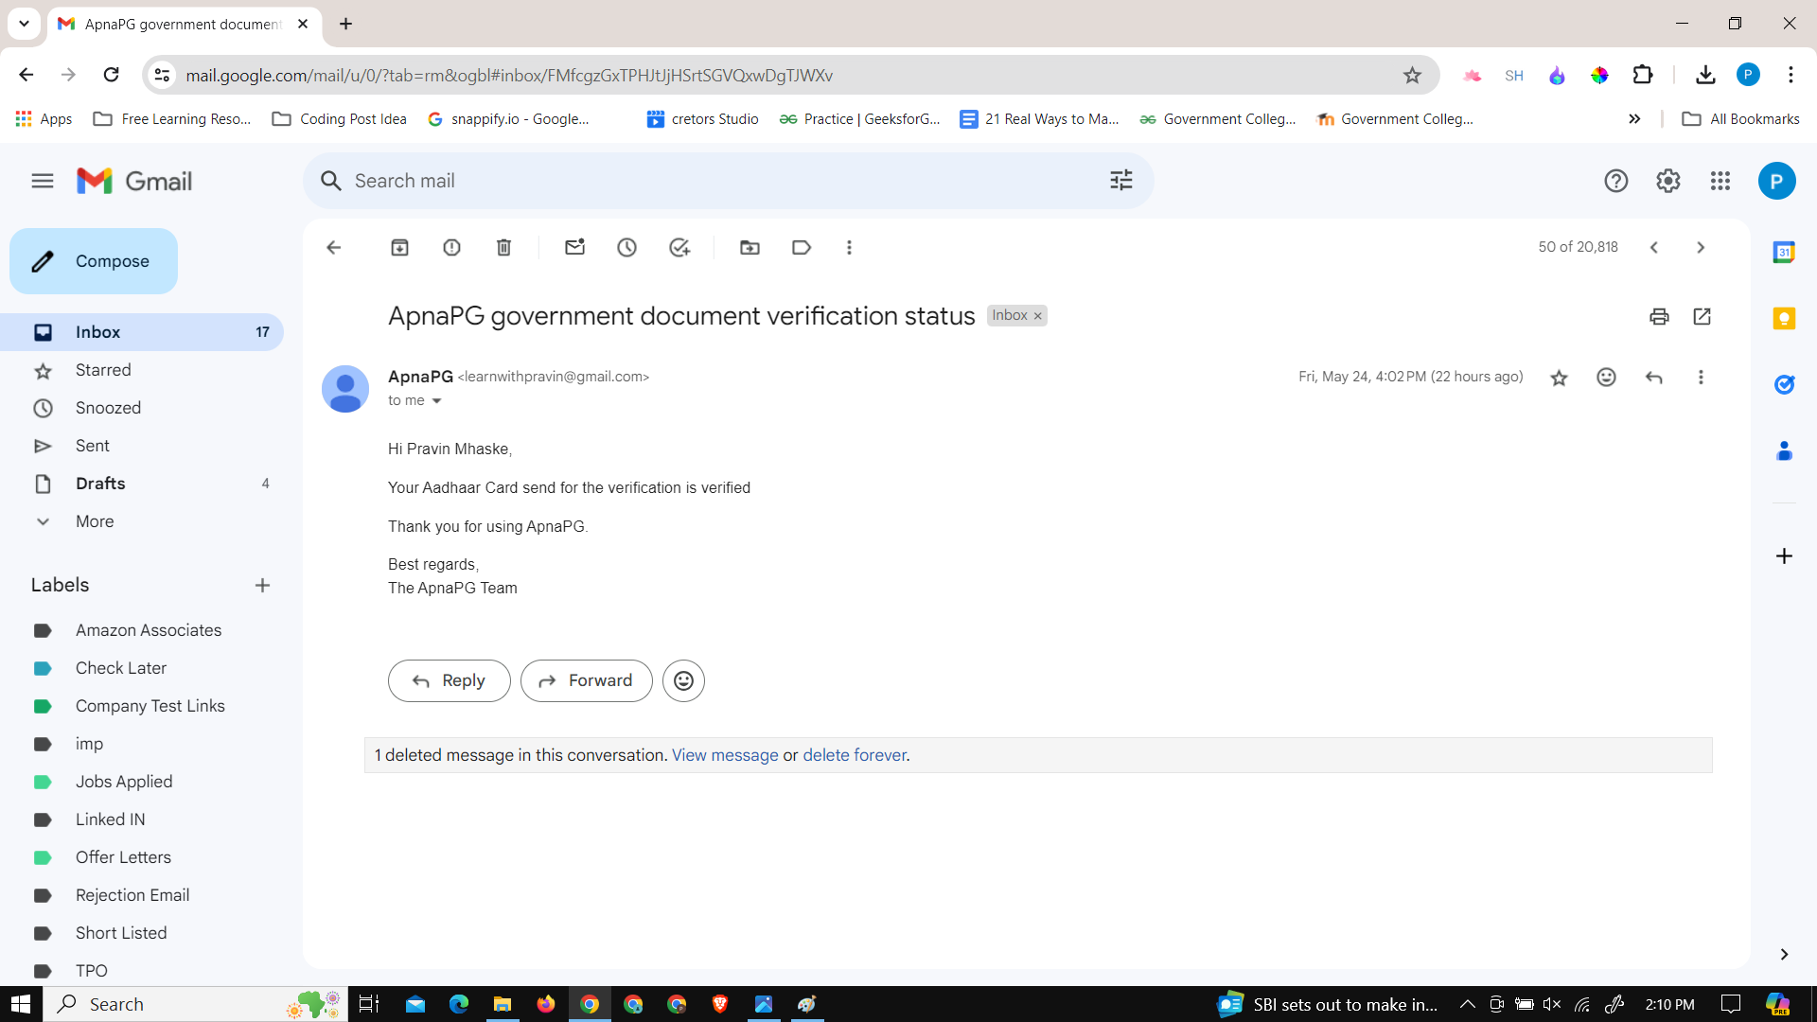

Figure 6. 28 Government document verification status

For document verification, users can select any government ID such as PAN card, Aadhar card, or driving license. Once the user submits the government ID, a notification is sent to the admin. The admin then checks the dashboard and verifies the ID. If the government ID is valid, the user receives a prompt stating that they have been officially verified.

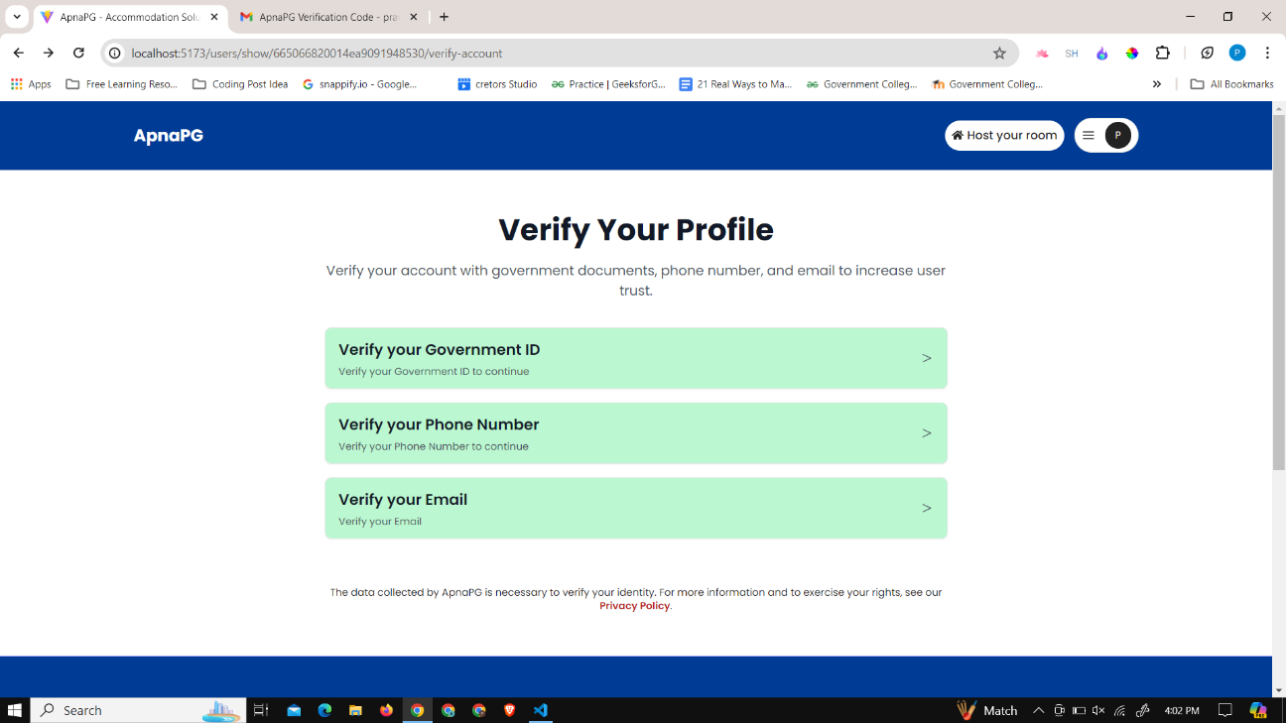

Figure 6. 29 Account verification status of the user

Once user verification is completed, users can proceed to book a room, allowing them to plan their accommodation according to their schedule and make reservations accordingly.

## 6.4 Booking of the room by the user (student/ bachelor’s)

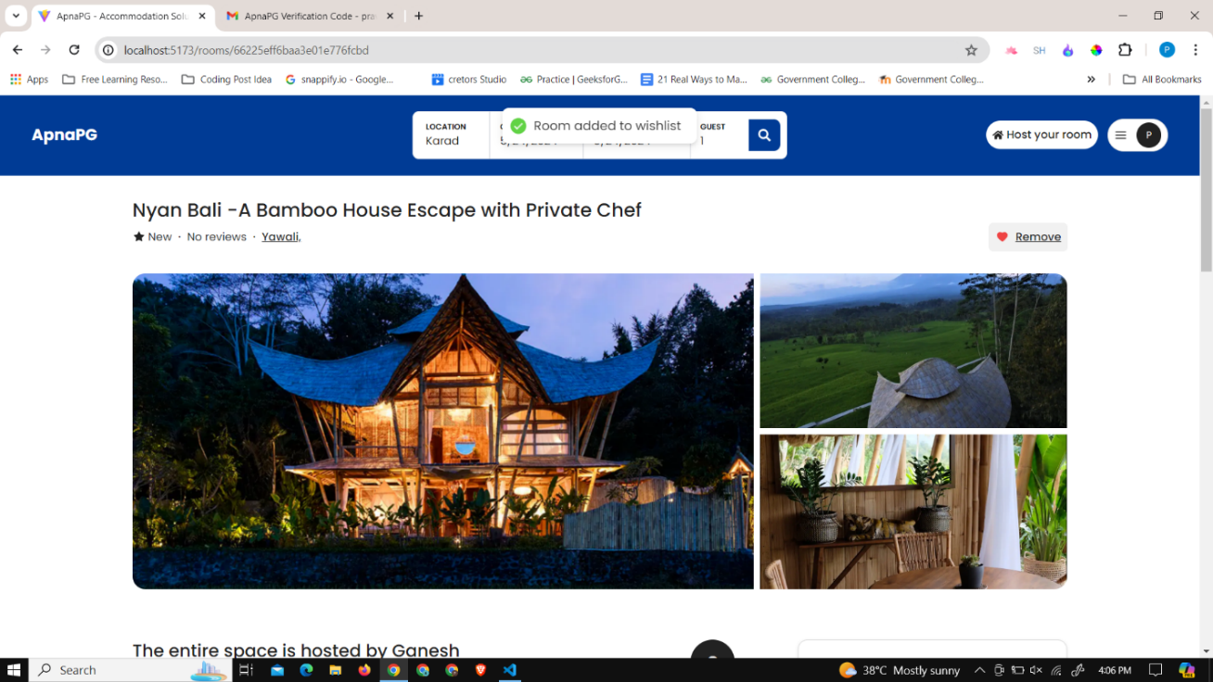

Figure 6. 30 Selected room details

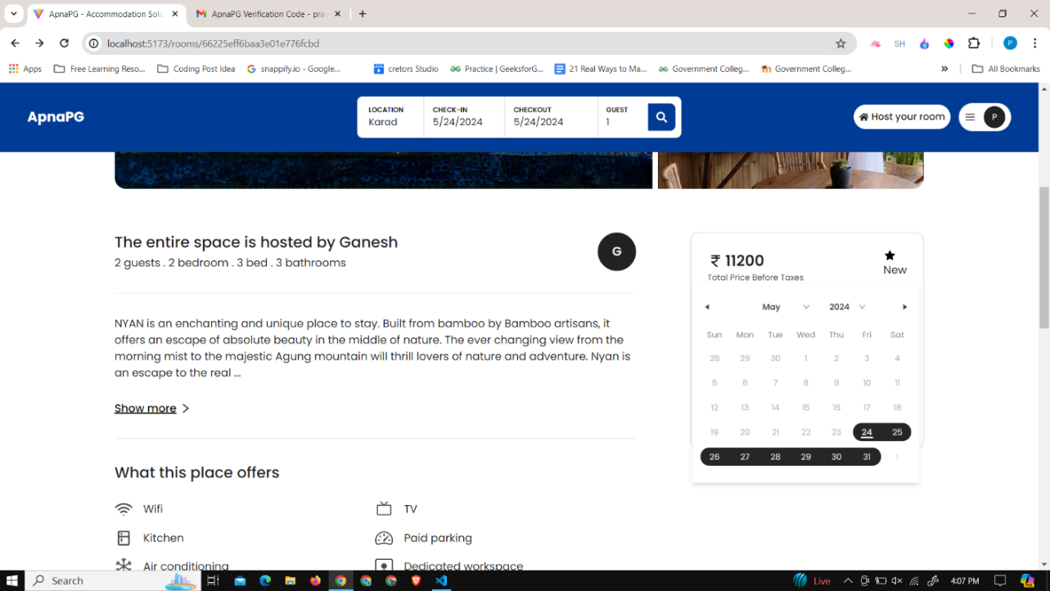

Figure 6. 31 Select room details – 2

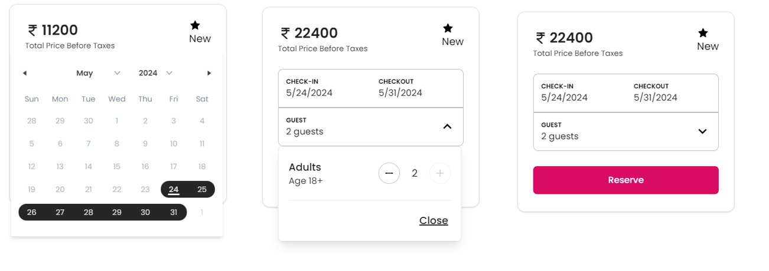

Figure 6. 32 Selection of the check In, checkout, and guest count for the booking

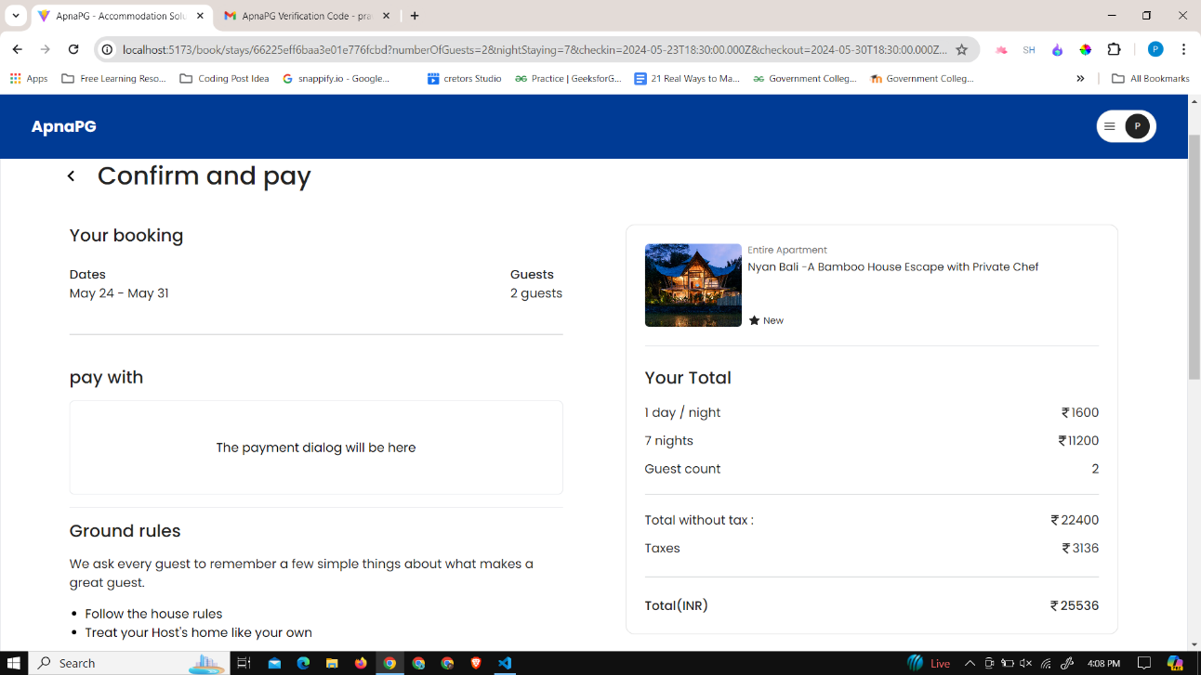

Figure 6. 33 Room checkout page

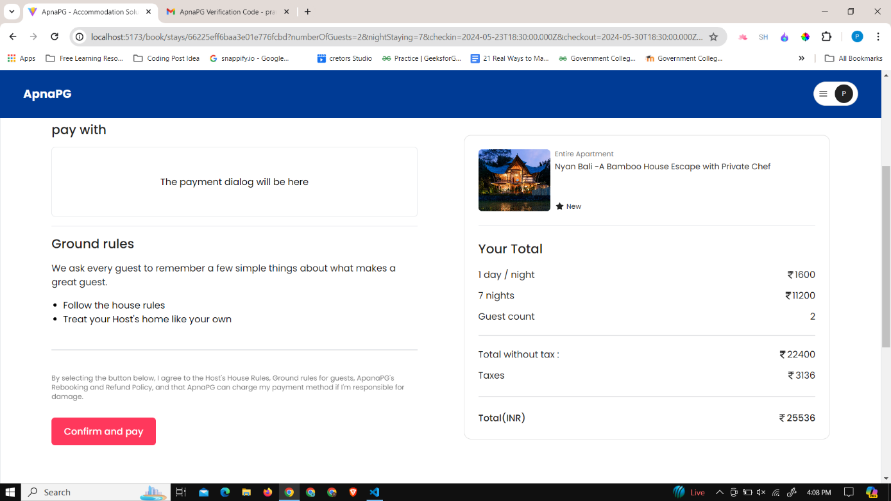

Figure 6. 34 Room checkout page - 2

Figure 6. 35 Room checkout page - 2

Once users find a room they like, they can proceed to enter their desired date and time slot, indicate the number of guests, specify the number of beds needed, and select any additional amenities they wish to avail. After providing these details, users can then reserve the room, securing their accommodation for the specified dates and ensuring a seamless booking experience.

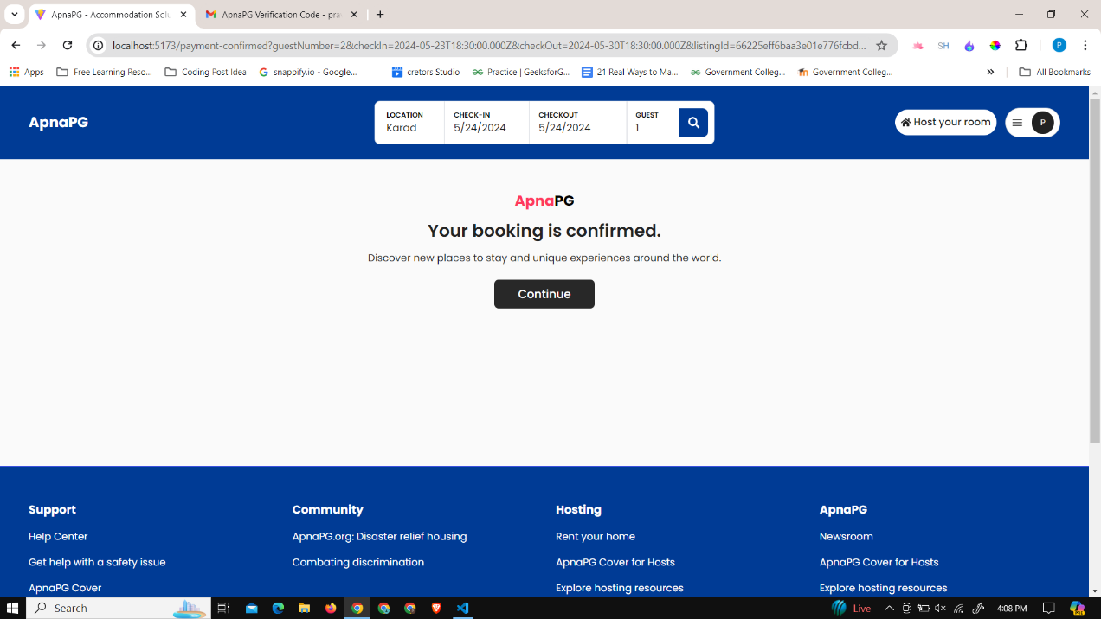

Figure 6. 36 Booking page status page

Once the transaction is completed, users can navigate to the booking page to access comprehensive details about their listing. Users have the option to cancel the booking within a 4-hour window.

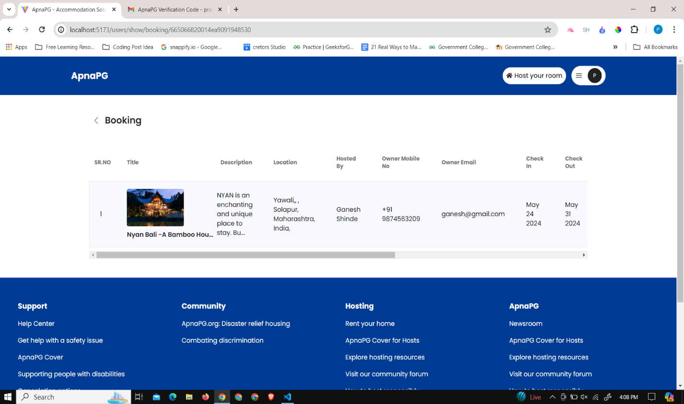

Figure 6. 37 User booking dashboard

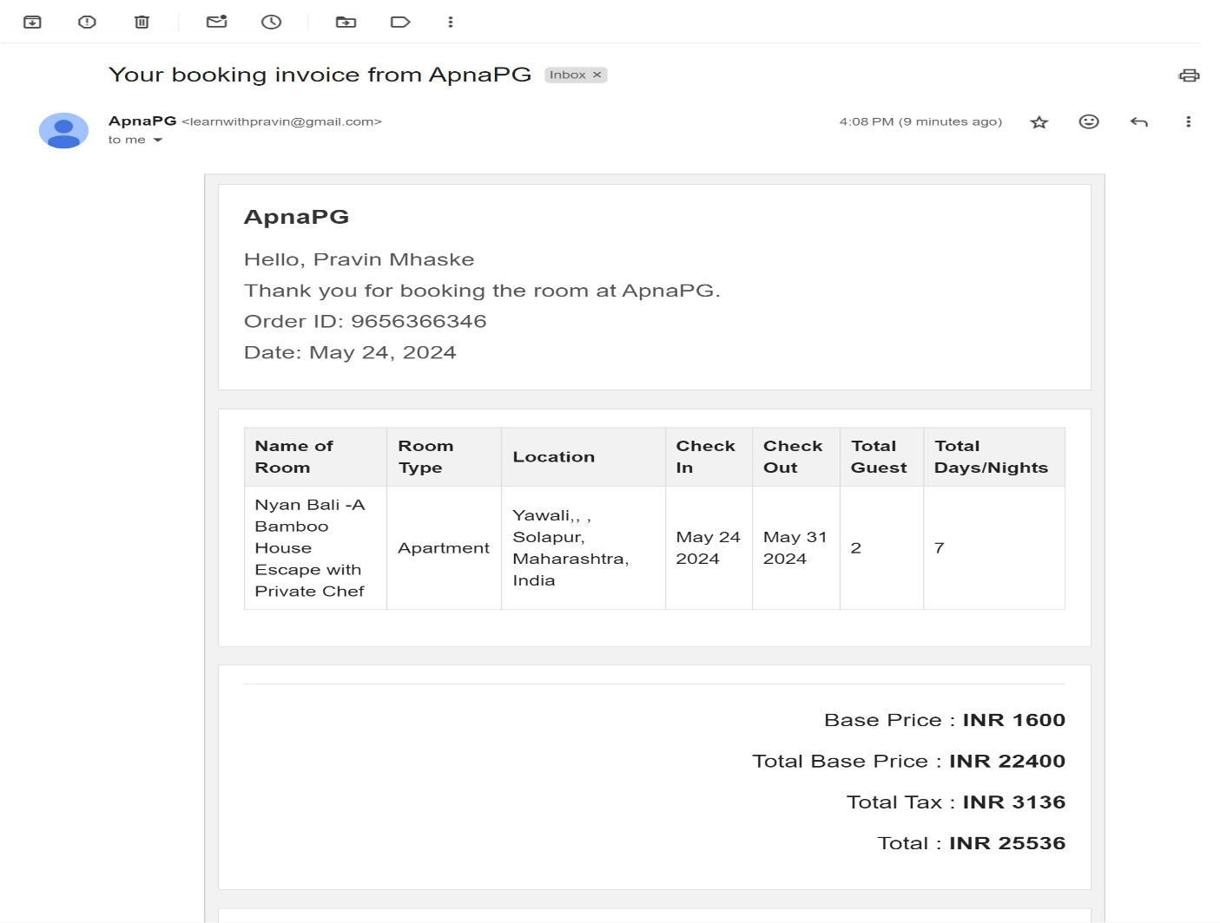

Figure 6. 38 ApnaPG Booking room invoice

Upon successful payment, users will receive a confirmation email along with an invoice delivered to their email address. This ensures users have documented proof of their reservation and payment transaction for their records. Additionally, the confirmation email serves as a reassurance of their booking and provides essential details regarding their upcoming stay.

## 6.5 Hosting of rooms by room owners

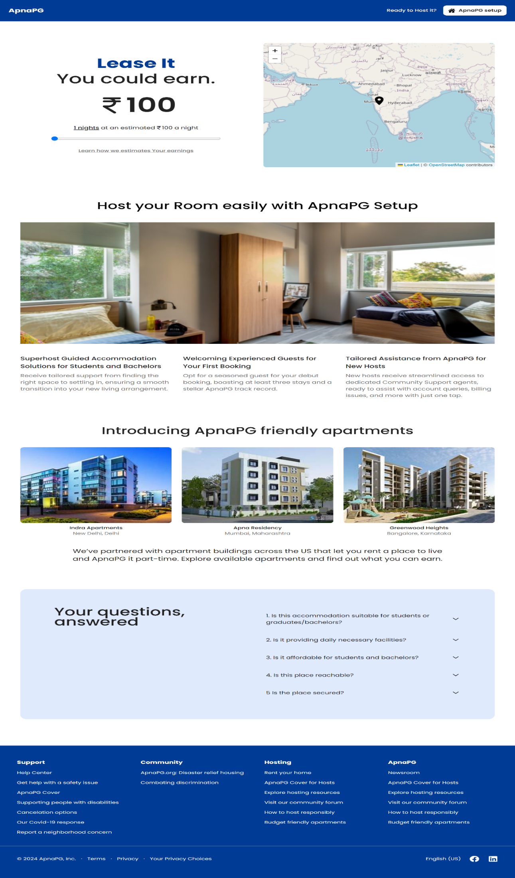

Figure 6. 39 Hosting room page

This is the homepage for hosting rooms, where room owners can find comprehensive details of users.

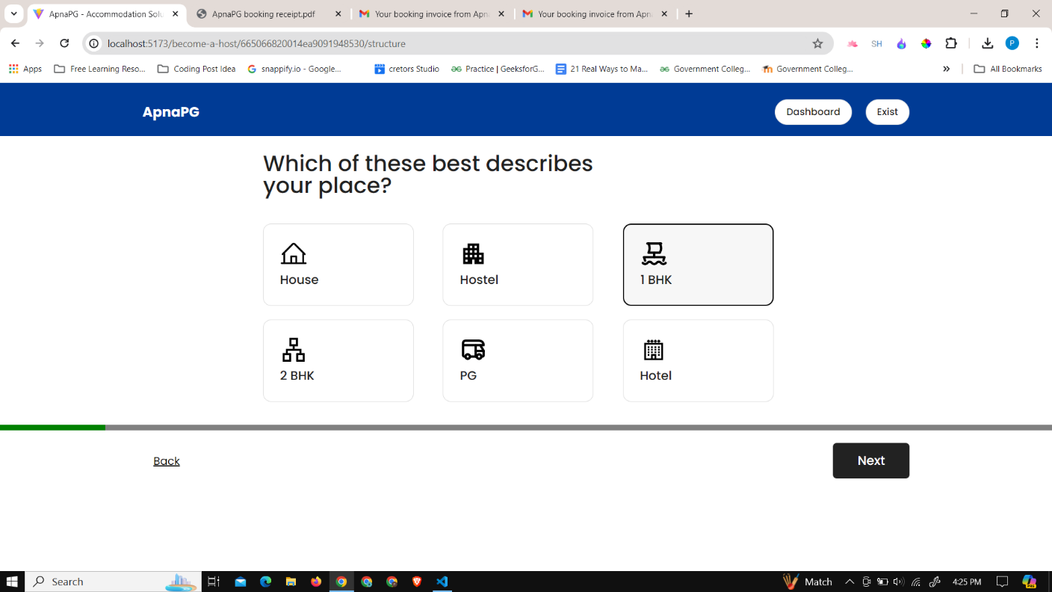

Figure 6. 40 Host room - select the room type

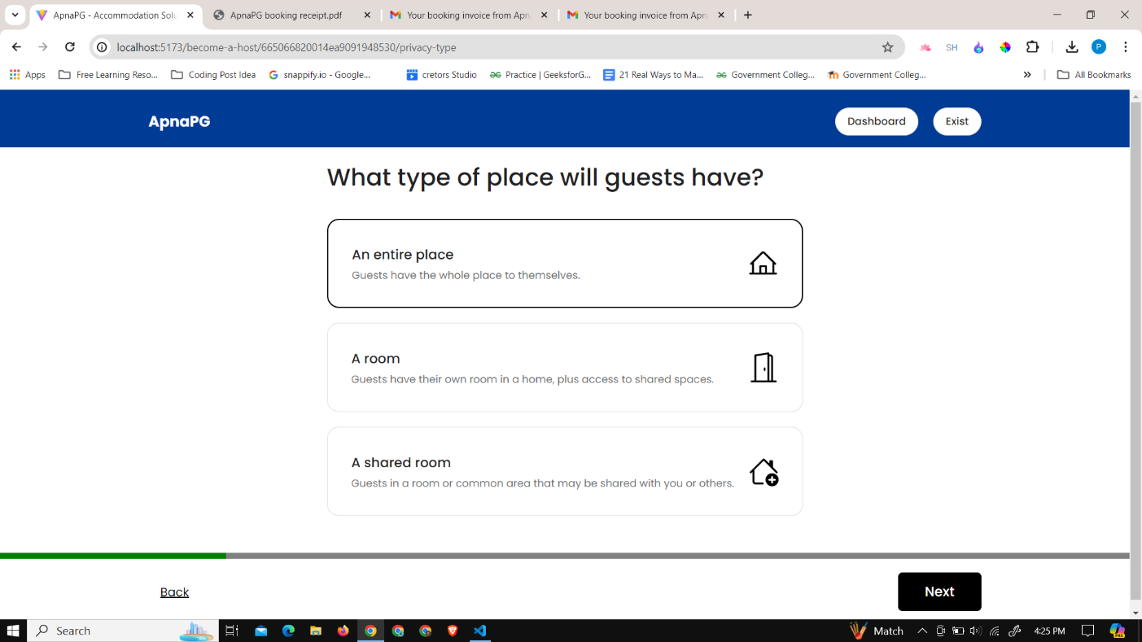

Figure 6. 41 Host room - select the room privacy

Room owners on ApnaPG can select from a variety of accommodation types, including 1BHK, 2BHK, PG, hostel, hotel, and houses. Additionally, they have the option to specify the privacy level of the room, choosing between shared spaces and entire rooms. This flexibility empowers room owners to cater to diverse guest preferences, ensuring a tailored and personalized booking experience for users.

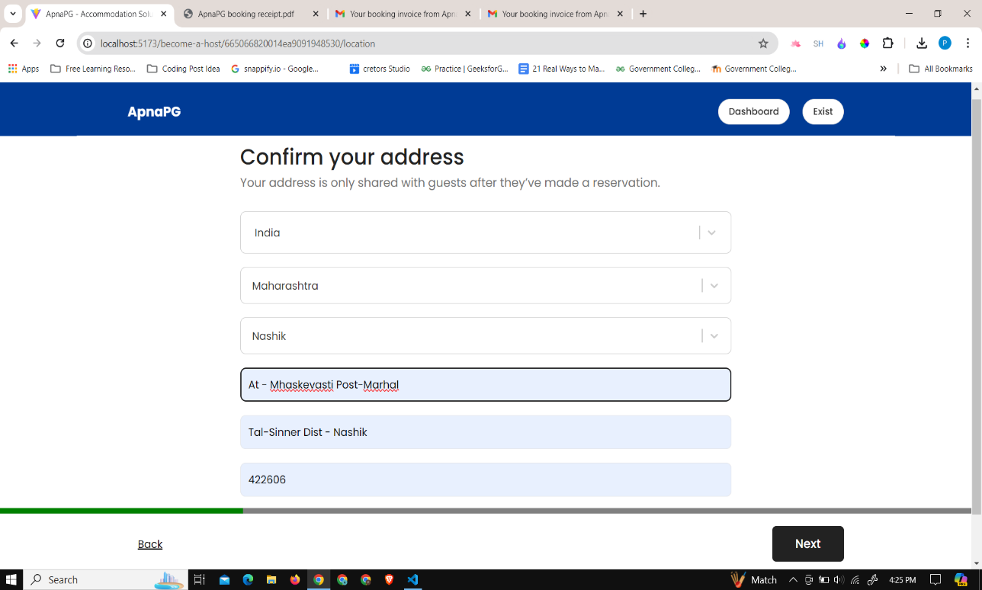

Figure 6. 42 Host room - add room address

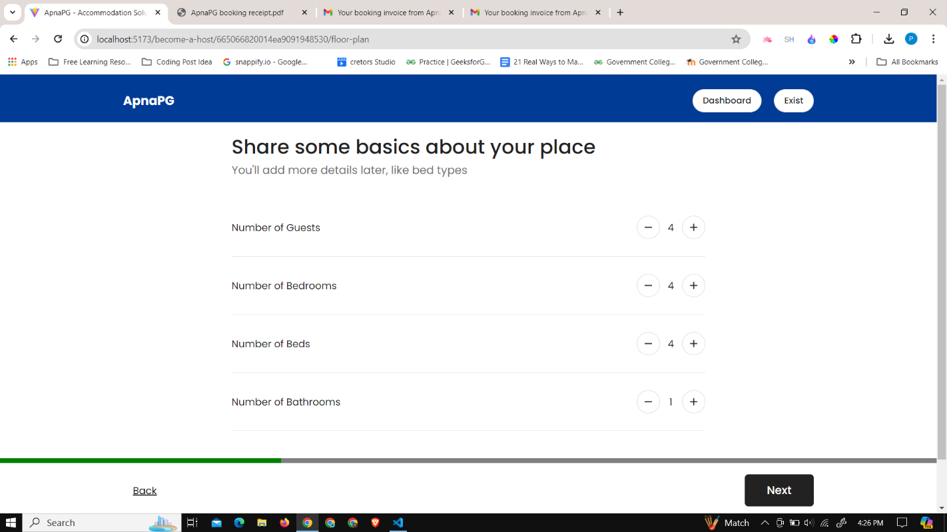

Figure 6. 43 Host Room - Select the floor plan

Owners furnish vital details including the accommodation's address, location on a map, guest capacity, bedroom and bathroom count, bed arrangements, and a brief description. This comprehensive information enables users to make well-informed booking decisions.

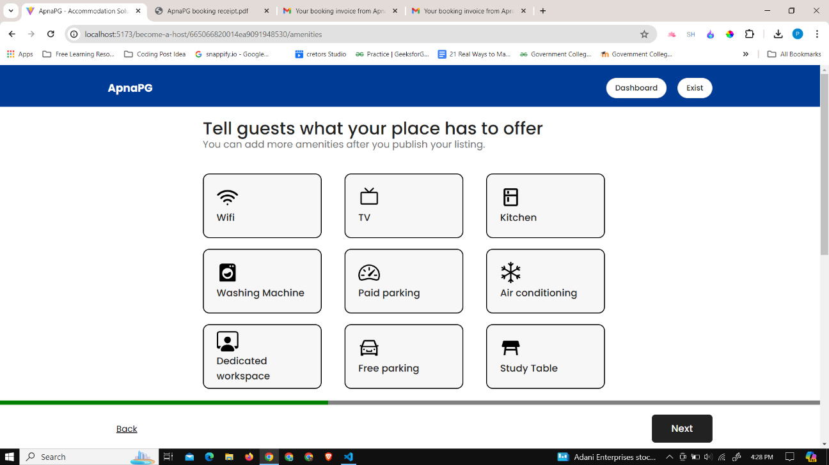

Figure 6. 44 Host room - add amenities

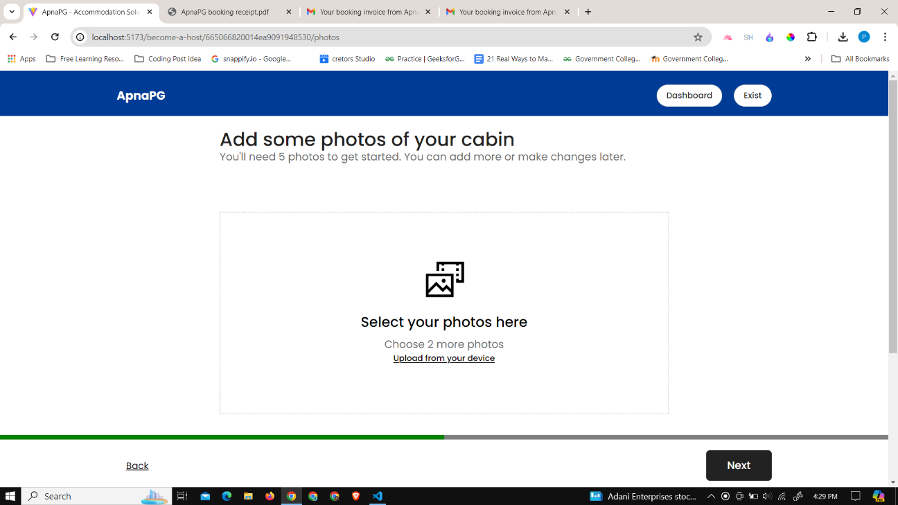

Figure 6. 45 Host room - upload room images

Room owners select amenities offered as part of room hosting, including WiFi, TV, kitchen, washing machine, fan, paid parking, free parking, study table, and chair. Additionally, users must provide at least three images of the rooms to enhance listing visibility.

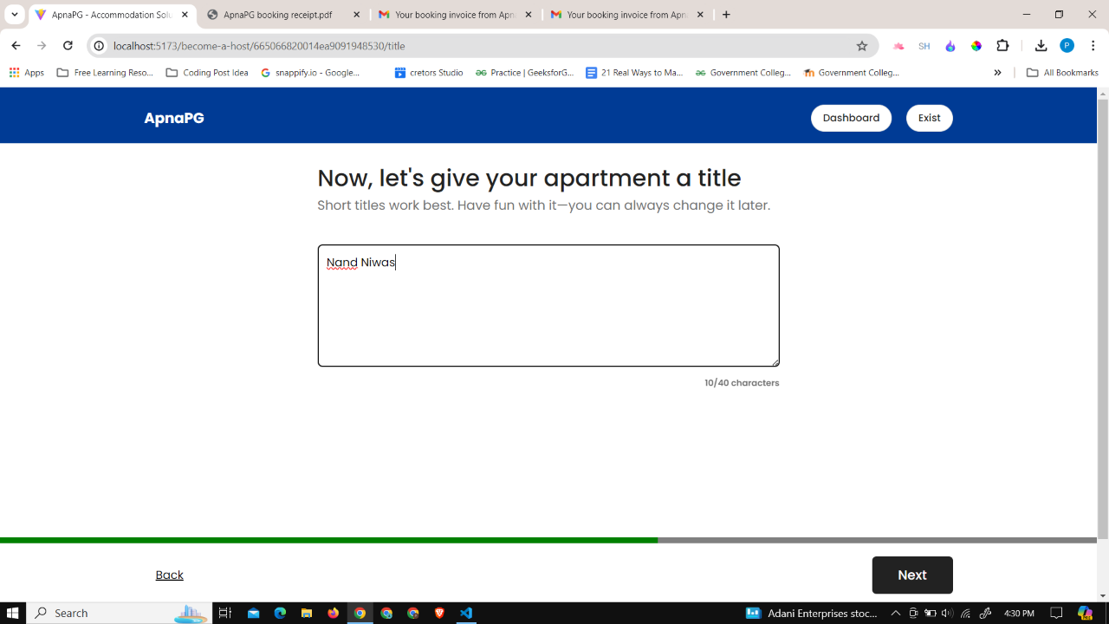

Figure 6. 46 Host room - give title to room

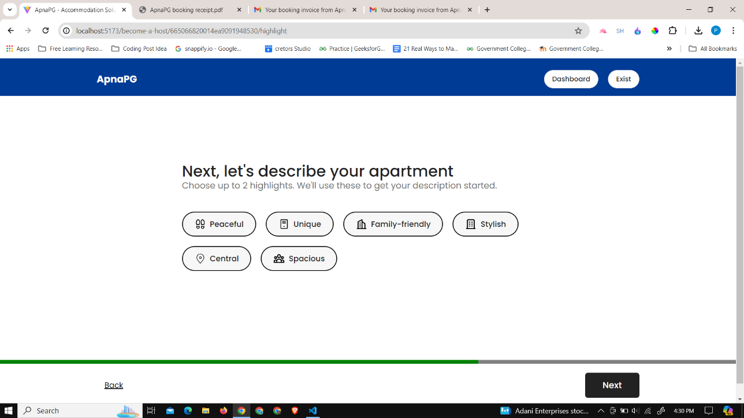

Figure 6. 47 Host room - Select the room highlights

Owners can entice users with captivating titles and descriptions, highlighting attributes like family-friendliness, spaciousness, style, and central location. This approach aims to attract potential guests by showcasing the unique features and appeal of the accommodation.

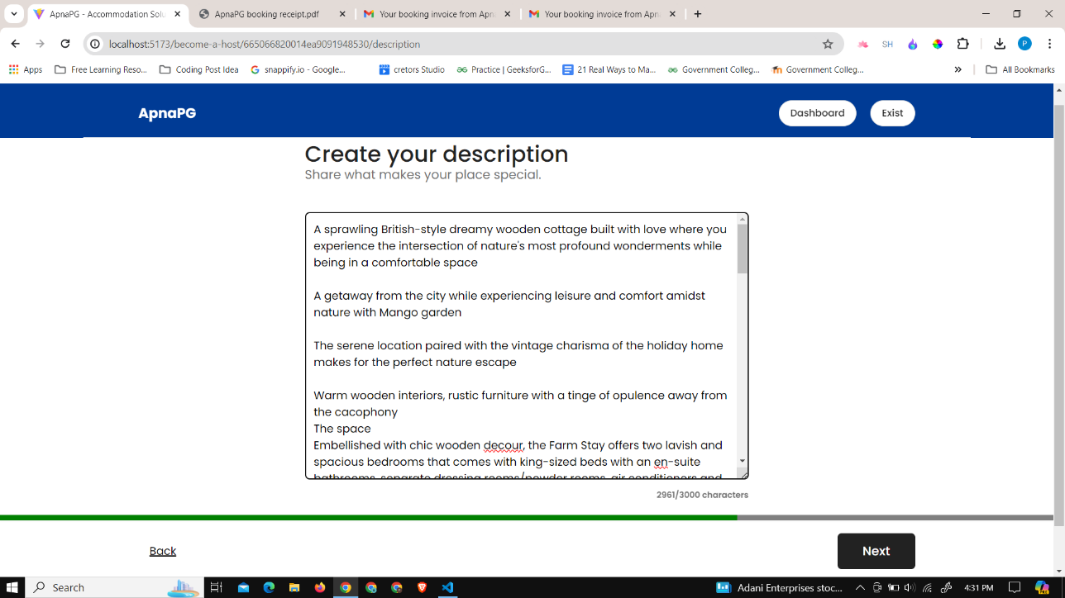

Figure 6. 48 Host room - room description

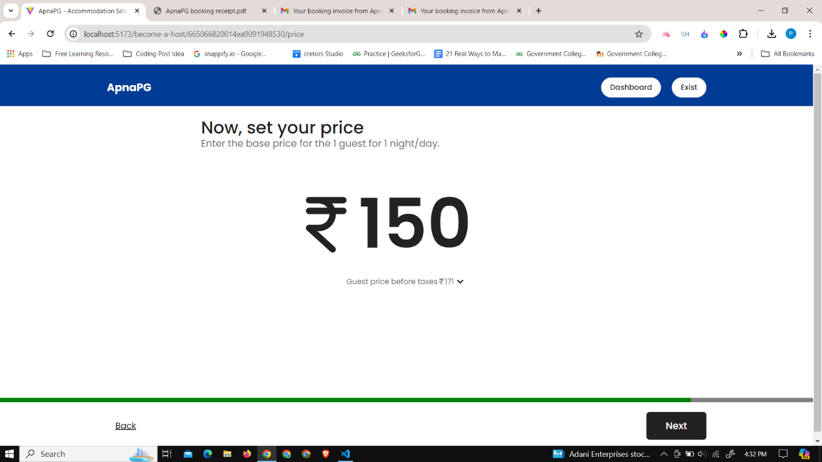

Figure 6. 49 Host room - Set the base price per day

Owners can describe their accommodations as family-friendly, spacious, stylish, and centrally located, inviting potential guests to experience comfort and convenience. With competitive pricing strategies, owners ensure affordability without compromising quality, making their listings accessible to all travelers.

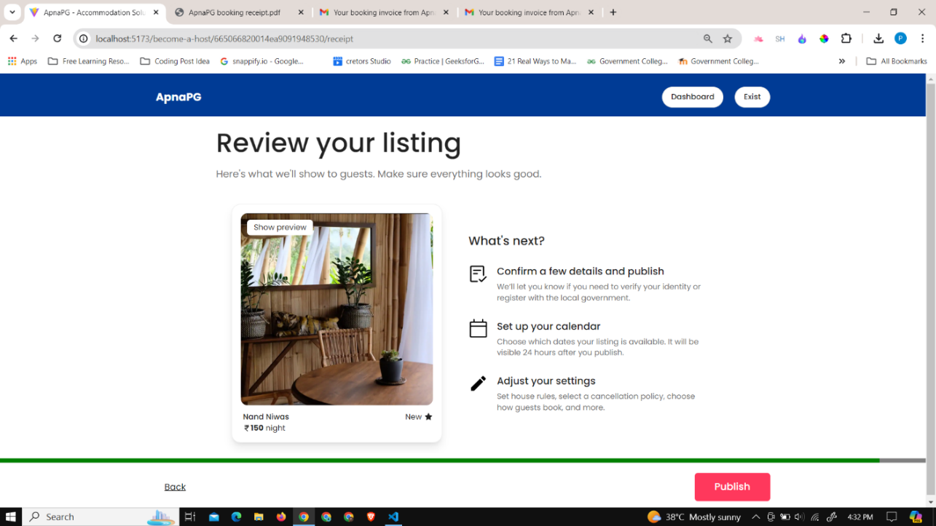

Figure 6. 50 Host room - publish the room

After completing the listing process, users are redirected to their personalized dashboard where they can manage and monitor their listings effectively.

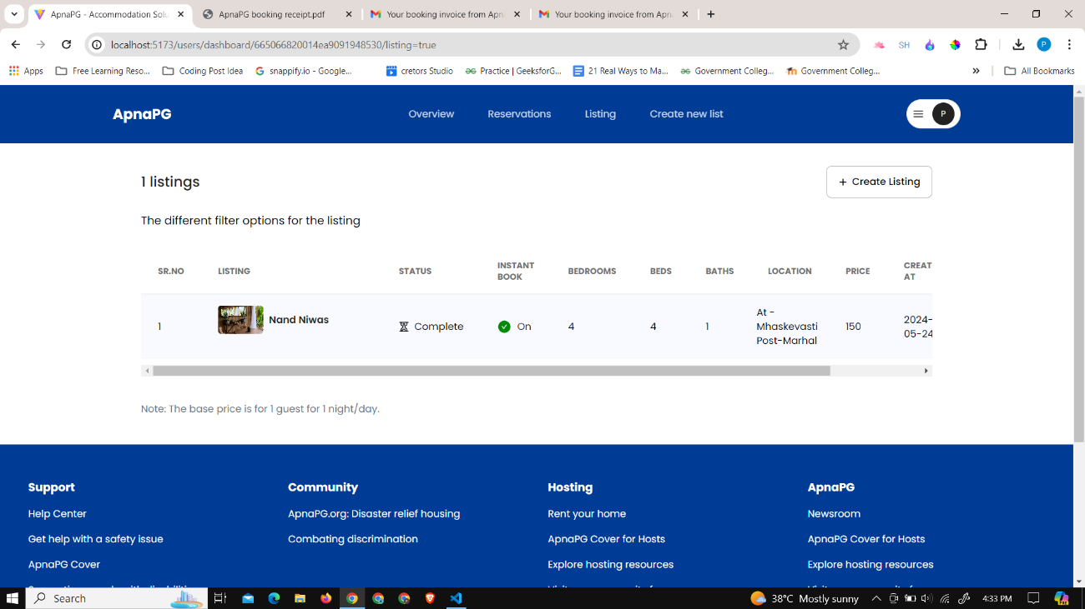

Figure 6. 51 User Dashboard - Listing

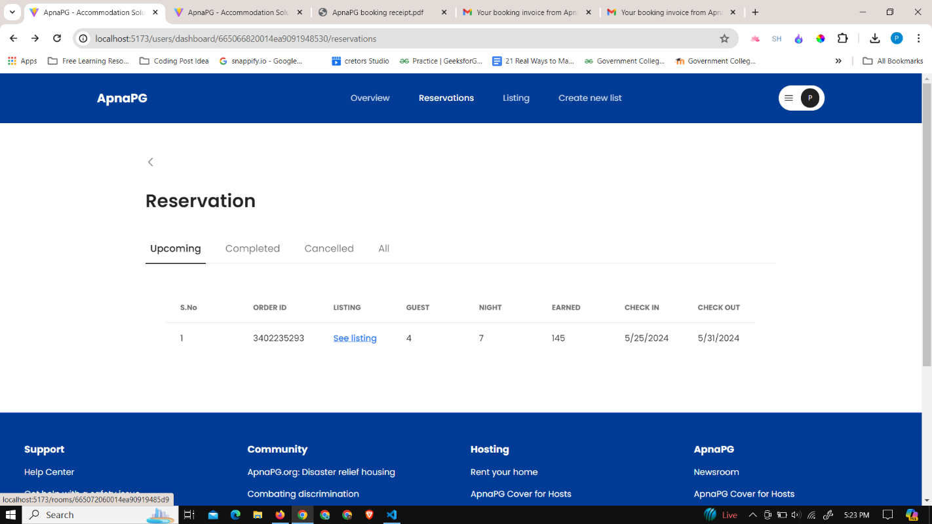

Figure 6. 52 User dashboard - Reservation details

This is the dashboard where users can manage their reservation listings, including viewing upcoming, completed, and canceled reservations, and much more. It provides a centralized platform for users to efficiently handle all aspects of their accommodation bookings.

In conclusion, the implementation of ApnaPG showcases a seamless user experience, emphasizing features like user registration, accommodation search, and booking process. The platform ensures trust and credibility through robust user account verification, while empowering room owners with comprehensive hosting options. With intuitive interfaces and efficient processes, ApnaPG stands as a reliable solution for both accommodation seekers and providers, promising convenience and effectiveness in the housing market.

# Chapter 7

# CONCLUSION AND FUTURE SCOPE

## 7.1 Conclusion

The "Accommodation Solution for Students and Bachelors - ApnaPG" project successfully addresses the critical need for a streamlined, user-friendly platform connecting users with affordable and reliable accommodation options. By integrating advanced search functionalities, a transparent pricing structure, and comprehensive verification processes, the platform ensures a secure and efficient user experience. The implementation of features such as document verification, personalized dashboards, and robust admin controls underscores the project's commitment to maintaining a trustworthy and user-centric environment. As ApnaPG continues to evolve, its potential for geographic expansion, enhanced security measures, and integration of innovative technologies promises to further transform the accommodation landscape, ultimately providing students and bachelors with a superior housing solution.

## 7.2 Future Scope

The accommodation solution for students and bachelors presented in this report addresses the immediate needs of the target demographic. However, the future offers numerous opportunities for expansion and improvement in this domain. The following are potential areas for future growth and development:

* **Chatbot Integration:**

Implement a basic chatbot using existing frameworks and libraries. Start with predefined responses for common queries related to accommodation search, pricing, and booking.

* **Machine Learning for Recommendation:**

Begin with simple recommendation algorithms based on user preferences and historical data. Implement a basic system that suggests accommodations similar to what users have shown interest in.

* **Geographic Expansion:**

Gradually expand the platform's coverage to nearby urban areas. This can be done by collaborating with accommodation providers in those regions and gradually increasing the database.

* **Smart Contracts for Agreements**

Explore existing blockchain platforms with smart contract functionality. Implement basic smart contracts for transparent rental agreements with standard terms and conditions.

* **Augmented Reality (AR) for Virtual Tours**

Start with basic AR features for providing virtual tours. Use existing AR libraries and frameworks to integrate simple visualization of accommodation spaces.

* **Voice Search and Control**

Begin with basic voice search functionality using available APIs. Allow users to search for accommodations and access basic information using voice commands.

* **Community Engagement Features**

Introduce basic community engagement features such as discussion forums. Allow users to share experiences and seek advice from the community.

* **App Building**

Develop mobile applications for both iOS and Android platforms to enhance accessibility and user experience. Focus on creating a user-friendly interface that allows for easy navigation, booking, and management of accommodations. Incorporate push notifications to keep users informed about new listings, booking updates, and community activities.

The accommodation solution for students and bachelors meets current needs and offers significant future growth opportunities. Key areas for expansion include integrating chatbots for customer support, using machine learning for personalized recommendations, geographic expansion, implementing smart contracts for transparent agreements, and incorporating augmented reality for virtual tours. These enhancements will improve functionality and user experience.

# REFERENCES

1. Park, J. W., & Doo, K. I. (2019). “Usability evaluation of social curation travel app for accommodation”. *Journal of Advanced Research in Dynamical and Control Systems*, *11*(Special Issue 8), 2006–2012.
2. Nathan, R. J., Victor, V., Tan, M., & Fekete-Farkas, M. (2020). “Tourists’ use of Airbnb app for visiting a historical city”. *Information Technology and Tourism*, *22*(2), 217–242. <https://doi.org/10.1007/s40558-020-00176-0>
3. Chaudhari, K., Thakkar, A. “A Comprehensive Survey on Travel Recommender Systems”. *Arch Computat Methods Eng* 27, 1545–1571 (2020). <https://doi.org/10.1007/s11831-019-09363-7>
4. Bang Nong, N., & Ha, V. H. T. (2023). “Impact of Covid-19 on Airbnb: evidence from Vietnam”. *Journal of Sustainable Finance and Investment*, *13*(1), 283–296. <https://doi.org/10.1080/20430795.2021.1894544>
5. Wang, Z., Huang, W. J., & Liu-Lastres, B. (2022). “Impact of user-generated travel posts on travel decisions: A comparative study on Weibo and Xiaohongshu”. *Annals of Tourism Research Empirical Insights*, *3*(2). <https://doi.org/10.1016/j.annale.2022.100064>
6. “Using mobile app for traveling: an example in Macedonia”. (2018). *HORIZONS.A*, *23*. <https://doi.org/10.20544/horizons.a.23.2.18.p53>
7. Tikoo, V., Jain, R., Sheth, P., & Dalvi, H. (2022). “MyRoomie: A Roommate Finding App”. *International Journal for Research in Applied Science and Engineering Technology*, *10*(3), 1937–1943. <https://doi.org/10.22214/ijraset.2022.40806>
8. Bellini, O. E., Gambaro, M., Gullace, M. T., Arcieri, M., Benito, C. Á., Rommane, S. B., … Figueira, M. F. (2023). Digital Infrastructure for Student Accommodation in European University Cities: The “HOME” Project. In *Urban Book Series* (Vol. Part F813, pp. 247–259). Springer Science and Business Media Deutschland GmbH. <https://doi.org/10.1007/978-3-031-29515-7_23>
9. Arzoumanidis, I., Petti, L., & Raggi, A. (2022). Online booking platforms: Towards making more sustainable choices. Cleaner Production Letters, 3, 100009. <https://doi.org/10.1016/j.clpl.2022.100009>
10. Worsley, J.D., Harrison, P. & Corcoran, R. The role of accommodation environments in student mental health and wellbeing. *BMC Public Health* **21**, 573 (2021). <https://doi.org/10.1186/s12889-021-10602-5>
11. Simpeh, F., & Shakantu, W. (2020). “An on-campus university student accommodation model”. Journal of Facilities Management, 18(3). <https://doi.org/10.1108/JFM-03-2020-0017>
12. Chua, J. F., Kee, D. M. H., Lee, M. J., Lim, C. H., Toh, Y. R., Raj, N., Goel, P., & Pandey, R. (2020). “A Study on Growing Trends, Customer Expectations and Perception towards Services Provided by OYO”. International Journal of Tourism and Hospitality in Asia Pasific, 3(2). <https://doi.org/10.32535/ijthap.v3i2.819>
13. Li, J., So, K. K. F., & Hudson, S. (2023). “Customer responses to the Airbnb platform: the role of Airbnb experience and memorability”. International Journal of Contemporary Hospitality Management, 35(3). <https://doi.org/10.1108/IJCHM-07-2022-0821>
14. Mbazor, D. N. (2021). Assessment of the Influence of on-Campus Housing Quality and Facilities on Students’ Academic Performance at the Federal University of Technology, Akure, Nigeria. Baltic Journal of Real Estate Economics and Construction Management, 9(1). <https://doi.org/10.2478/bjreecm-2021-0002>
15. Najib. (2011). “Measuring Satisfaction with Student Housing Facilities”. American Journal of Engineering and Applied Sciences, 4(1). <https://doi.org/10.3844/ajeassp.2011.52.60>
16. Ntouros, V., Laskari, M., Iordache-Platis, M., Assimakopoulos, M.-N., romanowicz, J., & Lontorfos, V. (2019). “Alleviating energy poverty experienced by students living in private rented accommodation: The role of the housing provider”. Proceedings of the International Conference on Business Excellence, 13(1). <https://doi.org/10.2478/picbe-2019-0088>
17. Kolawole, O. A., & Boluwatife, A. R. (2016). “Assessment Of The Factors Influencing Students’ Choice Of Residence In Nigerian Tertiary Institutions”. Sains Humanika, 8(2). <https://doi.org/10.11113/sh.v8n2.768>
18. Srairi, S. (2022). “An Analysis of Factors Affecting Student Dropout: The Case of Tunisian Universities”. International Journal of Educational Reform, 31(2). <https://doi.org/10.1177/10567879211023123>
19. Cahyani, N. P. E. Y., Astawa, I. K., & Triyuni, N. N. (2021). “Increasing Room Occupancy and Room Revenue through Price Decision Strategy”. International Journal of Glocal Tourism, 1(1). <https://doi.org/10.58982/injogt.v1i1.12>
20. de Pelsmacker, P., van Tilburg, S., & Holthof, C. (2018). “Digital marketing strategies, online reviews and hotel performance”. International Journal of Hospitality Management, 72. <https://doi.org/10.1016/j.ijhm.2018.01.003>